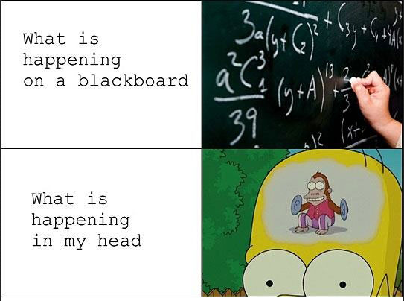
- Look up a similar problem in your CLASS NOTES.
Taking good notes includes:
  - Writing down EVERY step
  - Writing VERBAL EXPLANATIONS
  - HIGHLIGTING important information

- Look up a similar problem in your TEXTBOOK.

- Ask for help from a CLASSMATE or PARENT.

- GOOGLE it!
Some helpful sights:
www.mathtv.com
www.khanacademy.org

- Go to MATH LAB.

- Get a TUTOR.

How to Study for Math Class
- REWORK ENTIRE problems from the class notes.
- REWORK ENTIRE problems from the homework. (Remember: all odd answers are in the back of the textbook).
- REWORK ENTIRE problems from past quizzes.
Noticing a pattern? Often rereading or simply rewriting only a part of a problem will not be enough to help you understand and remember the process.
- Be sure to FIX ENTIRE problems that you got WRONG the first time.
If you made a mistake the first time, odds are you will make the same mistake again.
- REWORD definitions, properties, and formulas in LAYMAN’S TERMS.
Memorizing something you don’t understand will often not be helpful.

