***Chapter 2*** – Reasoning and Proof

In this chapter we address three Big IDEAS:

1. **Use inductive and deductive reasoning**
2. **Understanding geometric relationships in diagrams**
3. **Writing proofs of geometric relationships**

|  |  |
| --- | --- |
| Section: | **2– 1 Using inductive reasoning** |
| Essential Question | **How do you use inductive reasoning in mathematics?** |

Warm Up:

|  |
| --- |
|  |

Key Vocab:

|  |  |
| --- | --- |
| Conjecture | An unproven statement that is based on observations. |
| Inductive reasoning | A process of reasoning that includes looking for patterns and making conjectures |
| Counterexample | A specific case that shows a conjecture is false |

Show:

Ex 1: Describe how to sketch the fourth figure in the pattern

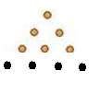

[th?id=I](http://www.bing.com/images/search?q=patterns+of+inductive+reasoning&view=detail&id=03646F5FFF0BB751E51B36AFFB596BDC09DC331B)

Ex 2: Describe how to sketch the fourth figure in the pattern.

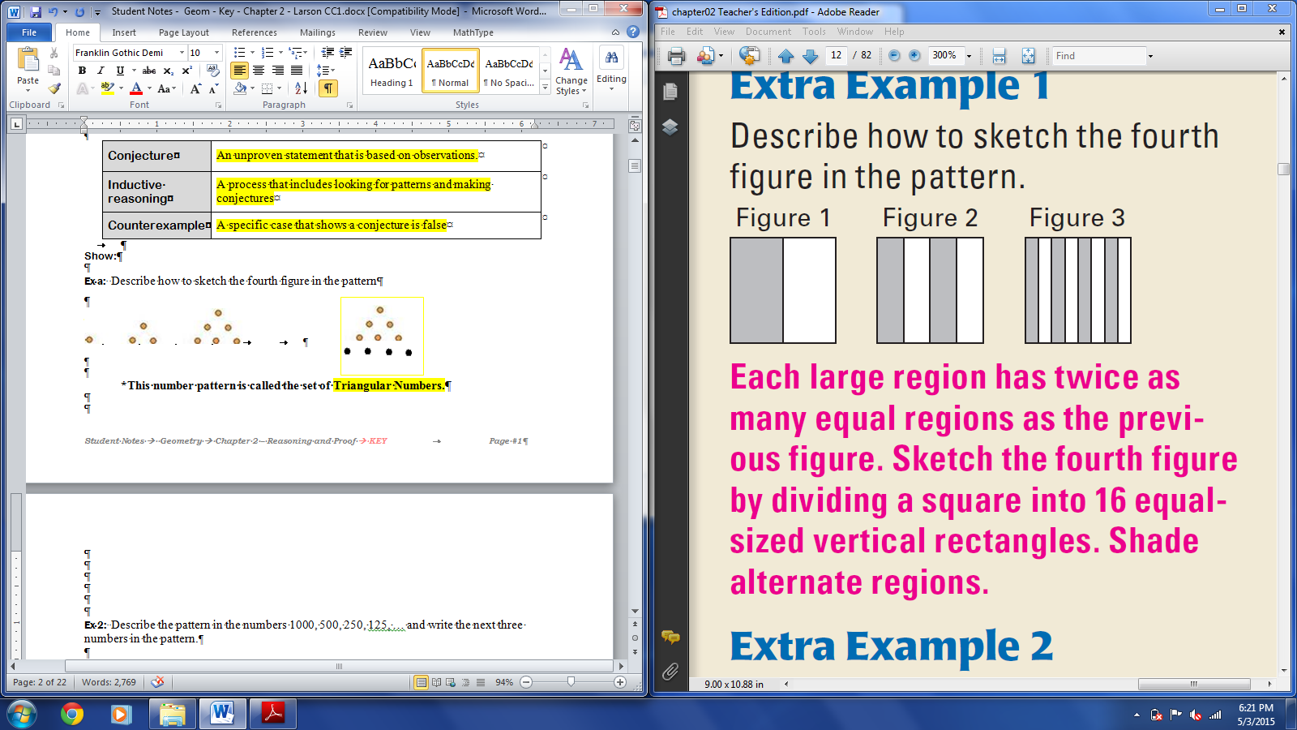

Each region is divided in half vertically. Figure 4 should have 16 equal-sized vertical rectangles with alternate rectangles shaded.

Ex 3: Given the pattern of triangles below, make a conjecture about the number of segments in a similar diagram with 5 triangles.

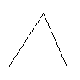 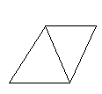 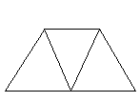

7 + 2 + 2 = 11 segments

Ex 4: Describe the pattern in the numbers and write the next TWO numbers in the pattern.

|  |  |  |
| --- | --- | --- |
| 1. 1000, 500, 250, 125, …   Each number in the pattern is one-half of the previous number:  **62.5, 31.25** | 1. 5.01, 5.03, 5.05, 5.07, …   Each number in the pattern increases by 0.02:  **5.09, 5.11** | The denominator and numerator each increase by one: |
|  |  |  |

Ex 5: Find a counterexample to disprove the conjecture:

**Conjecture:** Supplementary angles are always adjacent.

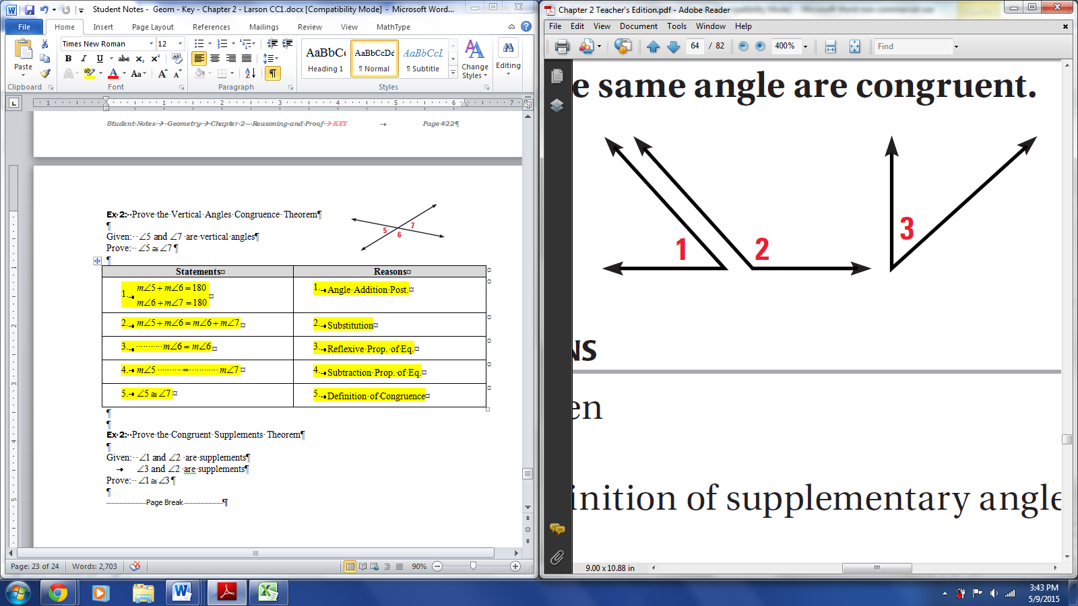

**Sample Ans**:

Ex 6: Find a counterexample to disprove the conjecture:

**Conjecture:** The value of is always greater than the value of *x*.

**Sample Ans:** If , then . Since , 

|  |  |
| --- | --- |
| Section: | **2 – 2 Analyze Conditional Statements** |
| Essential Question | How do you rewrite a biconditional statement? |

Warm Up:

|  |
| --- |
|  |



Key Vocab:

|  |  |  |
| --- | --- | --- |
| Conditional Statement | A type of logical statement that has two parts, a hypothesis and a conclusion. Typically written in "if, then" form  Symbolic Notation: | |
| Hypothesis | The “if” part of a conditional statement | |
| Conclusion | The “then” part of a conditional statement | |
| Negation | The opposite of a statement.  The symbol for negation is ~. | |
| Converse | The statement formed by exchanging the hypothesis and conclusion of a conditional statement. Not always true.  Symbolic Notation: | |
| Inverse | The statement formed by negating the hypothesis and conclusion of a conditional statement  Symbolic Notation: | |
| Contrapositive | The equivalent statement formed by exchanging AND negating the hypothesis and conclusion of a conditional statement  Symbolic Notation: | |
| Equivalent Statements | Two statements that are both true or both false  Ex. Conditional and Contrapositive; Converse and Inverse | |
| Biconditional Statement | A statement that contains the phrase “if and only if.”  Combines a conditional and its converse when both are true.  Ex. Definitions are biconditionals | |
| Perpendicular Lines | Two lines that intersect to form right angles  **Notation:** |  |

Show:

Ex 1: Rewrite the conditional statement in if-then form.

1. All whales are mammals.

If an animal is a whale, then it is a mammal.

1. Three points are collinear when there is a line containing them.

If there is a line containing three points, then the points are collinear.

Ex 2: Write the if-then form, the converse, the inverse, and the contrapositive of the statement, then determine the validity of each statement.

**Statement:** *Soccer players are athletes*

**Conditional**: If you are a soccer player, then you are an athlete. True.

**Converse**: If you are an athlete, then you are a soccer player. False.

**Inverse**: If you are not a soccer player, then you are not an athlete. False.

**Contrapositive**: If you are not an athlete, then you are not a soccer player. True.

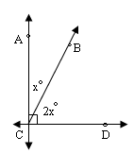Ex 3: Decide whether each statement about the diagram is true. Explain your answers using the definitions you have learned.

1. 

False

1. 

False

1. 

False

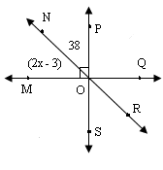Ex 4: Which equation can be used to find x?



Ex 5: Use the definition of *perpendicular lines* to write a conditional, a converse, and a biconditional.

**Conditional**: If two lines are perpendicular, then they intersect to form right angles.

**Converse**: If two lines intersect to form right angles, then they are perpendicular.

**Biconditional**:

Two lines are perpendicular if and only if they intersect to form right angles.

OR

Two lines intersect to form right angles if and only if they are perpendicular.

|  |  |
| --- | --- |
| Section: | **2 – 3 Apply Deductive Reasoning** |
| Essential Question | How do you construct a logical argument? |

Warm Up:

|  |
| --- |
|  |

Key Vocab:

|  |  |
| --- | --- |
| Deductive Reasoning | A process that uses facts, definitions, accepted properties, and the laws of logic to form a logical argument. |

Key Concepts:

|  |  |
| --- | --- |
| Law of Detachment | the hypothesis of a true conditional statement is true,  **then** the conclusion is also true. |
| Law of Syllogism | If **hypothesis p**, then **conclusion q**. If **hypothesis q**, then **conclusion r**.  **Therefore,**  If **hypothesis p**, then **conclusion r**. |

Show:

Ex 1: Use the Law of Detachment to make a valid conclusion in the true situation.

1. If two angles are right angles, then they are congruent.  and are right angles. 
2. If John is enrolled at Metro High School, then John has an ID number. John is enrolled at Metro High School. John has an ID number.

Ex 2: *If possible*, use the Law of Syllogism to write a new conditional statement that follows from the pair of true statements.

1. If Joe takes Geometry this year, then he will take Algebra 2 next year. If Joe takes Algebra 2 next year, then he will graduate. If Joe takes Geometry this year, then he will graduate.
2. If then *y* = 2. If *y* = 2, then 3*y* + 4 = 10. If  then 
3. If the radius of a circle is 4 ft, then the diameter is 8 ft. If the radius of a circle is 4 ft, then its area is  ft2. not possible

Ex 3: Tell whether the statement is a result of inductive reasoning or deductive reasoning. Explain your choice.

1. Whenever it rains in the morning, afternoon baseball games are cancelled. The baseball game this afternoon was not cancelled. So, it did not rain this morning.

Deductive reasoning: because it uses the laws of logic.

1. Every time Tom has eaten strawberries, he had a mild allergic reaction. The next time he eats strawberries, he will have a mild allergic reaction.

Inductive reasoning: because it is based on a pattern of events.

1. Jerry has gotten a sunburn every time he has gone fishing. The next time he goes fishing, he will get a sunburn.

Inductive reasoning: because it is based on a pattern of events.

|  |  |
| --- | --- |
| Section: | **2 – 4 Use Postulates and Diagrams** |
| Essential Question | How can you identify postulates illustrated by a diagram? |

Warm Up:

|  |
| --- |
|  |



Key Vocab:

|  |  |  |
| --- | --- | --- |
| Line Perpendicular to Plane | A line that intersects the plane in a point and is perpendicular to every line in the plane that intersects it at that point.  **Notation:** |  |

Point, Line, and Plane Postulates:

|  |
| --- |
| * Through any two points there exists exactly one line |
| * A line contains at least two points |
| * If two lines intersect, then their intersection is exactly one point. |
| * Through any three noncollinear points there exists exactly one plane |
| * A plane contains at least three noncollinear points |
| * If two points lie in a plane, then the line containing them lies in the plane |
| * If two planes intersect, then their intersection is a line. |

Show:

Ex 1: State the postulate illustrated by the diagram.

|  |  |
| --- | --- |
| Through any two points there exists exactly one line. | If two points lie in a plane, then the line containing them lies in the plane. |

Ex 2: Use the diagram to write examples of the given postulates.

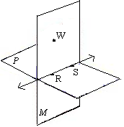

**a.** If two points lie in a plane, then the line containing them lies in the plane

**Sample answer:** Points *W* and *S* lie in plane *M*, so  lies in plane *M*.

**b.** If two planes intersect, then their intersection is a line.

The intersection of planes *P* and *M* is.

Ex 3: Sketch a diagram showing  at segment *GE’*s midpoint M.

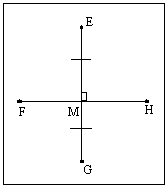

Ex 4: Which of the following cannot be assumed from the diagram?

|  |  |
| --- | --- |
|  | * *A*, *B*, and *C* are collinear  * at *B*. * Line * Points *B, C,* and *X* are collinear |

Ex 5: Classify each statement as true or false AND give the definition, postulate, or theorem that supports your conclusion**.**

|  |  |
| --- | --- |
| **F** | 1. A given triangle can lie in more than one plane. |
|  | **Reason**:Through any three noncollinear points there exists exactly one plane |
| **T** | 2. Any two points are collinear. |
|  | **Reason**:Through any two points there is exactly one line. |
| **F** | 3. Two planes can intersect in only one point. |
|  | **Reason**:If two planes intersect, then their intersection is a line. |
| **F** | 4. Two lines can intersect in two points. |
|  | **Reason**:If two lines intersect, then they intersect in exactly 1 point. |

|  |  |
| --- | --- |
| Section: | **2 – 5 Reason Using Properties from Algebra** |
| Essential Question | How do you solve an equation? |

Warm Up:

|  |
| --- |
|  |



Key Concepts:

|  |  |
| --- | --- |
| Algebraic Properties of Equality | |
| let *a, b,* and *c* are real numbers | |
| Addition Property | If *a* = *b*, then *a* + *c* = *b* + *c*. |
| Subtraction Property | If *a* = *b*, then *a* – *c* = *b* – *c*. |
| Multiplication Property | If *a* = *b*, then *ac* = *bc*. |
| Division Property | If *a* = *b* and c 0, then . |
| Substitution Property | If *a* = *b*, then *a* can be substituted for *b* in any equation or expression. |
| Distributive Property |  |

|  |  |
| --- | --- |
| Reflexive Properties of Equality | |
| Real Numbers | For any real number *a, a* = *a.* |
| Segment Lengths | For any segment *AB*, *AB* = *AB.* |
| Angle Measures | For any angle *A*, . |

|  |  |
| --- | --- |
| Symmetric Properties of Equality | |
| Real Numbers | For any real numbers *a* and *b,* if *a = b* ,then *b = a*. |
| Segment Lengths | For any segments *AB* and *CD*, if *AB = CD*, then *CD = AB.* |
| Angle Measures | For any angles *A* and *B*, if , then . |

|  |  |
| --- | --- |
| Transitive Properties of Equality | |
| Real Numbers | For any real numbers *a, b,* and *c*, if *a = b* and *b = c*, then *a = c*. |
| Segment Lengths | For any segments *AB, CD,* and *EF*, if *AB = CD* and *CD = EF*, then *AB = EF.* |
| Angle Measures | For any angles *A, B,* and *C,* if  and , then . |

Show:

Ex 1: Solve  Write a reason for each step.

|  |  |
| --- | --- |
| **Steps** | **Reasons** |
|  | 1. Given |
|  | 1. Addition Property of Equality |
|  | 1. Subtraction Property of Equality |
|  | 1. Division Property of Equality |
|  |  |

Ex 2: Solve   Write a reason for each step.

|  |  |
| --- | --- |
| **Steps** | **Reasons** |
|  | 1. Given |
|  | 1. Distributive Property |
|  | 1. Subtraction Property of Equality |
|  | 1. Division Property of Equality |
|  |  |
|  |  |

|  |  |
| --- | --- |
| Ex 5:  intersect at  so that . Show that |  |

|  |  |
| --- | --- |
| **Steps** | **Reasons** |
|  | 1. Given |
|  | 1. Addition Prop of Eq. |
|  | 1. Segment Addition Postulate |
|  | 1. Substitution |

|  |  |
| --- | --- |
| Ex 6: The city is planning to add two stations between the beginning and end of a commuter train line. Use the information given. Determine whether *RS* = *TU.* |  |

|  |  |
| --- | --- |
| **Steps** | **Reasons** |
|  | 1. Given |
| 1. ; | 1. Segment Addition Postulate |
|  | 1. Substitution Prop. of Eq. |
|  | 1. Reflexive Property of Eq. |
|  | 1. Subtraction Property of Eq. |

Ex 7: In the diagram.

Show that.

|  |  |
| --- | --- |
| **Statements** | **Reasons** |
|  | 1. Given |
|  | 1. Angle Addition Postulate |
|  | 1. Substitution Prop. of Eq. |
|  | 1. Reflexive Property of Eq. |
|  | 1. Subtraction Property of Eq. |

|  |  |
| --- | --- |
| Section: | **2– 6 Prove Statements about Segments and Angles** |
| Essential Question | How do you write a geometric proof? |

Warm Up:

|  |
| --- |
|  |

Key Vocab:

|  |  |
| --- | --- |
| Proof | A logical argument that shows a statement is true. |
| Two-Column Proof | A type of proof written as numbered statements and corresponding reasons that show an argument in a logical order. |
| Congruent Segments | Two segments are congruent IFF they have equal lengths:   * If two segments are congruent, then they have equal lengths. * If two segments have equal lengths, then are congruent. |
| Congruent Angles | Two angles are congruent IFF they have equal measures   * If two angles are congruent, then they have equal measures. * If two angles have equal measures, then they are congruent. |

Theorems:

|  |  |
| --- | --- |
| Congruence of Segments | |
| Segment congruence is reflexive, symmetric and transitive | |
| Reflexive |  |
| Symmetric | If |
| Transitive | If |

|  |  |
| --- | --- |
| Congruence of Angles | |
| Angle congruence is reflexive, symmetric, and transitive. | |
| Reflexive |  |
| Symmetric | If |
| Transitive | If |

Show:

Ex 1: Name the property illustrated by each statement.

1. 

Symmetric Property

1. 

Transitive Property

1. 

Reflexive Property

Ex 2: Give a valid conclusion then write the appropriate definition, postulate, or theorem to justify the conclusion.

1. Given: 

Conclusion: 

Justification: Definition of Congruent Segments

1. Given: 

Conclusion: 

Justification: Definition of a Midpoint

1. Given: are complementary

Conclusion: 

Justification: Definition of Complementary Angles

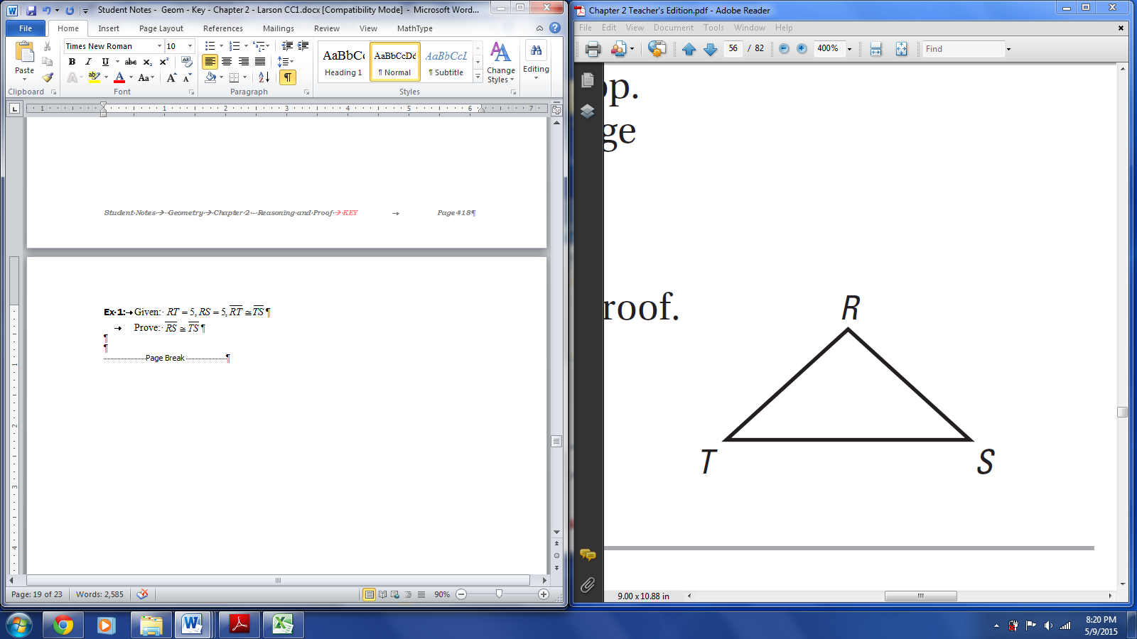Ex 3: Given: 

Prove: 

|  |  |
| --- | --- |
| **Statements** | **Reasons** |
|  | 1. Given |
|  | 1. Transitive Property |
|  | 1. Definition of Congruence |
|  | 1. Given |
|  | 1. Transitive Property |

3

1

4

2

# **D**

# **C**

# **A**

# **B**

Ex 4: Given: 





Prove: 

|  |  |
| --- | --- |
| **Statements** | **Reasons** |
|  | 1. Given |
|  | 1. Definition of Angle Bisector |
|  | 1. Transitive Property |

|  |  |
| --- | --- |
| Section: | **2 – 7 Prove Angle Pair Relationships** |
| Essential Question | What is the relationship between angles supplementary/complementary to the same angle? |

Warm Up:

|  |
| --- |
|  |

Theorems:

|  |  |
| --- | --- |
| **Right Angles Congruence Theorem** | |
| All right angles are congruent. |  |

|  |  |
| --- | --- |
| **Vertical Angles Congruence Theorem** | |
| Vertical angles are congruent  and |  |

|  |  |  |
| --- | --- | --- |
| **Congruent Supplements Theorem** | | |
| **If**  two angles are supplementary to the same angle (or to congruent angles), | **then**  the two angles are congruent. |  |
| are supplementary &  are supplementary |  |

|  |  |  |
| --- | --- | --- |
| **Congruent Complements Theorem** | | |
| **If**  two angles are complementary to the same angle (or to congruent angles), | **then**  the two angles are congruent |  |
| are complementary &  are complementary |  |

|  |  |  |
| --- | --- | --- |
| **Linear Pair Postulate** | | |
| **If**  Two angles form a linear pair | **then**  they are supplementary |  |
| form a linear pair |  |

Show:

Ex 1: Find the indicated measure.

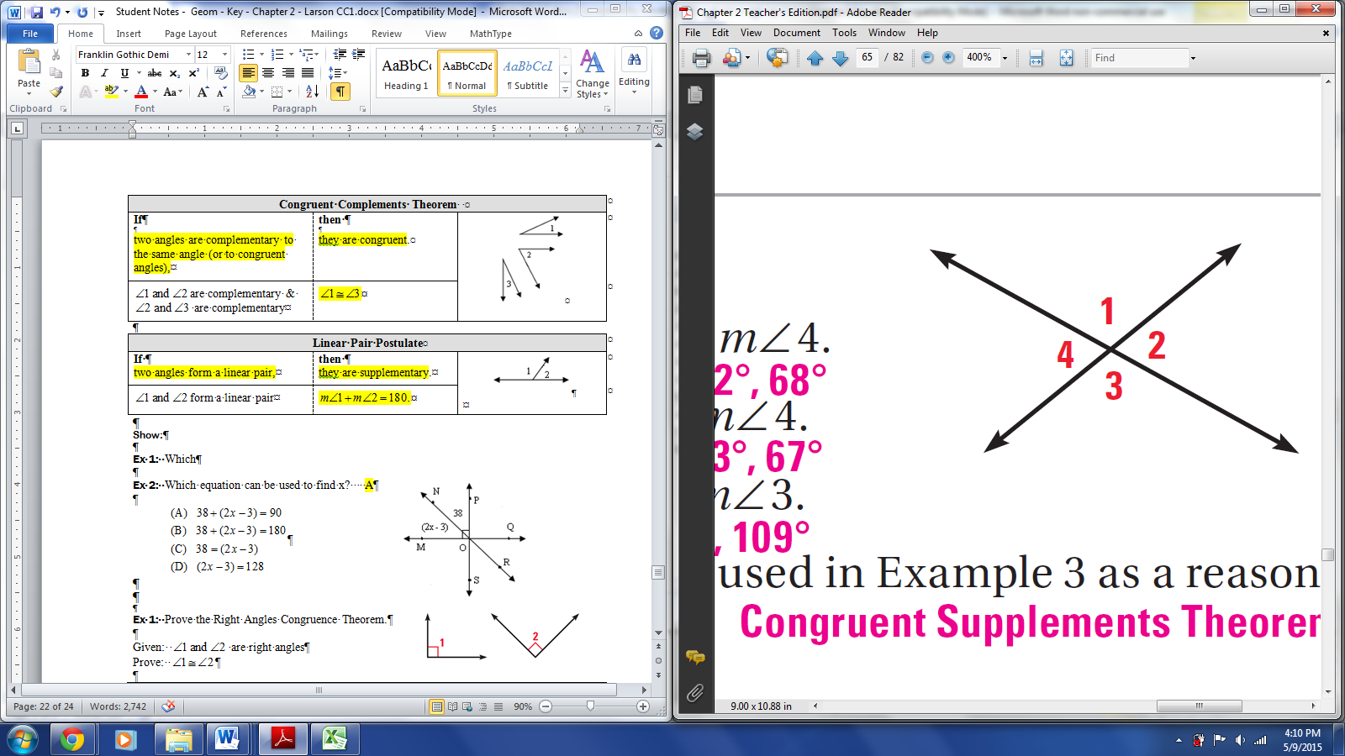

1. If , find 

by the vertical angles cong. thm.

180 - 112 = by the linear pair post.

1. , find 

by the vertical angles cong. thm.

180 - 71 = by the linear pair post.

Ex 2: Give a valid conclusion then write the appropriate definition, postulate, or theorem to justify the conclusion.

1. Given: are supplementary

 are supplementary

Conclusion: 

Justification: Congruent Supplements Theorem

1. Given: are complementary

 are complementary



Conclusion: 

Justification: Congruent Complements Theorem

Ex 3: Solve for *x*, then write the theorem or postulate that justifies your solution.

|  |  |
| --- | --- |
| 1. Reason: Linear Pair Postulate or Definition of Supplementary ’s | 1. Reason: Vertical Congr. Thm. |

Ex 4: In the diagram at the right, 

1. 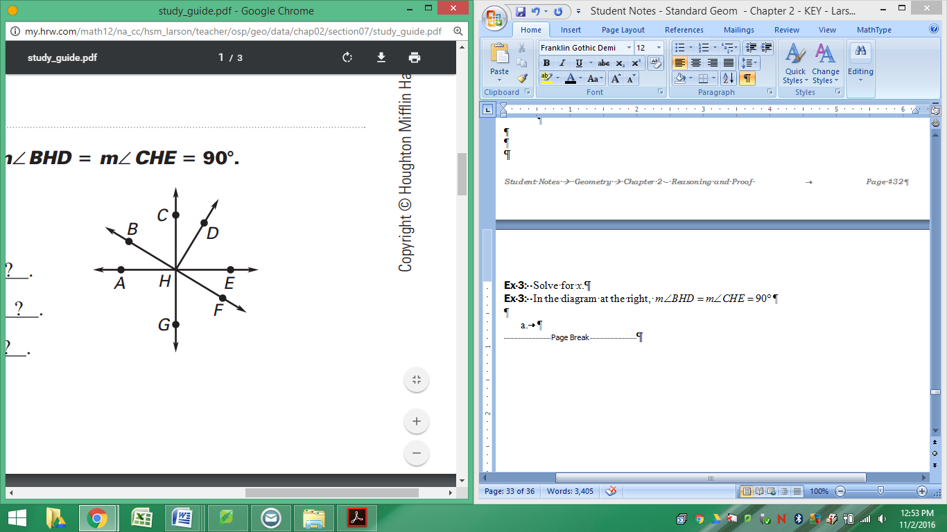
2. 
3. If .
4. If .

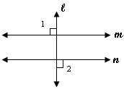Ex 5: Write a proof.

Given: 

Prove: 

|  |  |
| --- | --- |
| **Statements** | **Reasons** |
|  | 1. Given |
| 1. are right | 1. Definition of Perpendicular |
|  | 1. Right Angles Congruence Theorem |

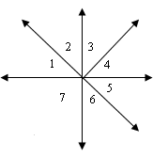

Ex 6: Write a two-column proof.

Given: 

Prove: 

|  |  |
| --- | --- |
| **Statements** | **Reasons** |
|  | 1. Given |
|  | 1. Vertical Angles Cong. Theorem |
|  | 1. Transitive |