***Chapter 11*** – Measurements of Figures and Solids

In this chapter we address three Big IDEAS:

1. **Comparing measures for parts of circles and the whole circle**
2. **Solving problems using surface area and volume**
3. **Connecting similarity to solids**

|  |  |
| --- | --- |
| Section: | **11 – 1 Circumference and Arc Length** |
| Essential Question | **How do you find the length of an arc of a circle?** |

Warm Up:

|  |
| --- |
|  |

Key Vocab:

|  |  |  |
| --- | --- | --- |
| Circumference | The distance around a circle: | |
| Semicircle | An arc with endpoints that are the endpoints of a diameter of a circle.  Half a circle | |
| Arc Length | A portion of the circumference of a circle |  |

Show:

Ex 1: Find the indicated measure. Round answers to the nearest hundredths.

|  |  |
| --- | --- |
| **a.** Circumference of a circle with radius 15 in. | **b.** Radius of a circle with circumference 36 ft. |

Ex 2: The diameter of a bicycle tire is 30 inches. To the nearest foot, how far does the tire travel when it makes 100 revolutions?

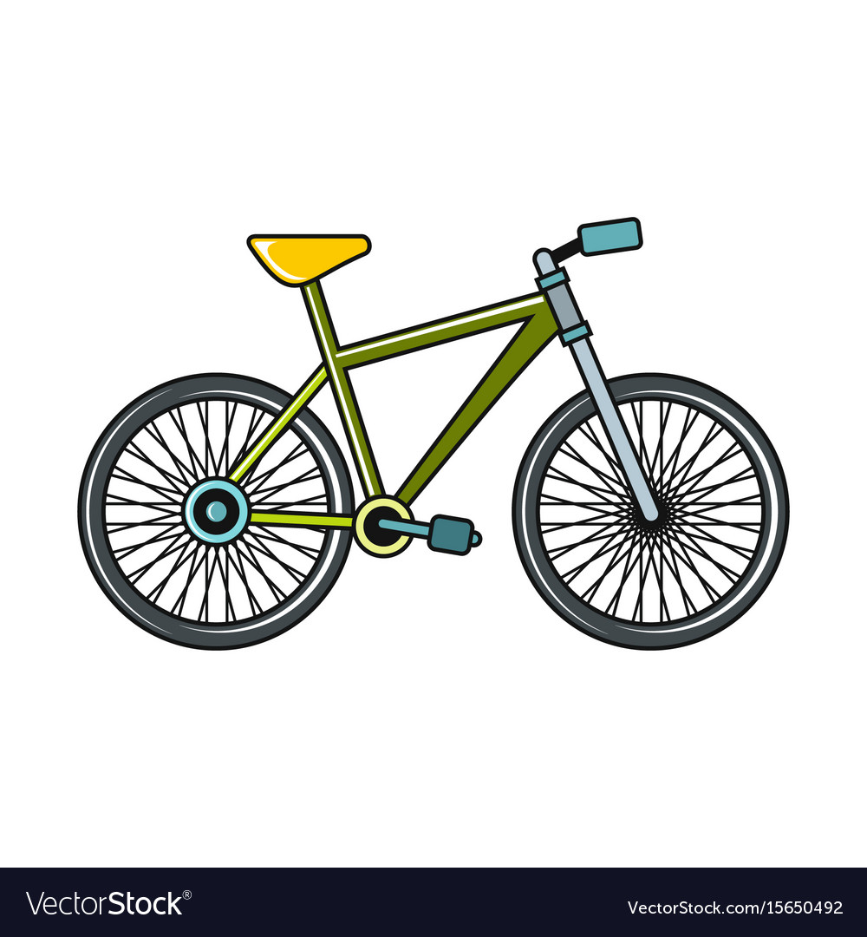



Ex 3: Find the length of each arc . Round answers to the nearest hundredths.

|  |  |  |
| --- | --- | --- |
| **a.**  180 | **b.** | **c.** |

Ex 4: Find the indicated measure. Where appropriate, round answers to the nearest hundredths.

|  |  |
| --- | --- |
| **a.** Find the circumference of *T.* | **b.** Find the  Length of |

|  |  |
| --- | --- |
| Section: | **11 – 2 Areas of Circles and Sectors** |
| Essential Question | How do you find the area of a sector of a circle? |

Warm Up:

|  |
| --- |
|  |



Key Vocab:

|  |  |  |
| --- | --- | --- |
| Area of a Circle |  | |
| Sector of a Circle | The region bounded by two radii of the circle and their intercepted arc. | Sector *APB* |
| Area of a Sector | The ratio of the area of a sector of a circle to the area of the whole circle |

Show:

Ex 1: Find the indicated measure of the circle.

|  |  |
| --- | --- |
| **a.** Area of the circle | **b.** Diameter |

Ex 2: Find the areas of the sectors formed by.

Area of smaller sector: Area of larger sector:

 



Ex 3: Use the diagram to find the area of .

 

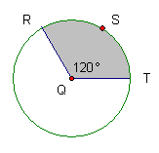

Area of shaded sector = 48

Ex 4: In this large circular painting, two white congruent circles just fit into a gray circle. What is the area that appears gray?

|  |  |
| --- | --- |
| **A.)** 18 | **B.)** 56.55 |
| **C.)** 75.40 | **D.)** 84.82 |

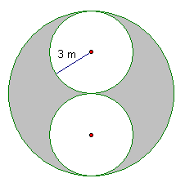

|  |  |
| --- | --- |
| Section: | **11 – 6 Volume of Prisms and Cylinders** |
| Essential Question | How do you find the volume of a right prism or right cylinder? |

Warm Up:

|  |
| --- |
|  |



Key Vocab:

|  |  |
| --- | --- |
| Volume | The number of cubic units contained in the interior of a solid. |

Formulas:

|  |  |  |
| --- | --- | --- |
| Volume of a Cube | ,  where *s* is the length of a side. | *s* |
| Volume of a Prism | ,  where *B* is the area of the base and *h* is the height. |  |
| Volume of a Cylinder | ,  where *B* is the area of the base, *h* is the height, and *r* is the radius of the base. |  |

Postulates and Theorems:

|  |  |
| --- | --- |
| Volume Congruence Postulate | |
| **If**  two polyhedra are congruent, | **then**  they have the same volume. |

|  |  |
| --- | --- |
| Cavalieri’s Principle | |
| **If**  two solids have the same height and the same cross-sectional area at every level, | **then**  they have the same volume. |

|  |
| --- |
| Volume Addition Postulate |
| The sum of the parts equals the whole |
| The volume of a solid is the sum of the volumes of all its *nonoverlapping* parts. |

Show:

Ex 1: Find the volume of the puzzle piece. (Assume the piece is divided into congruent cubes)

1 in



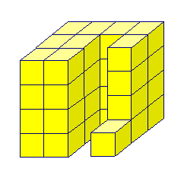

Ex 2: The volume of the cubic gift box is. Find the value of *x*.



x

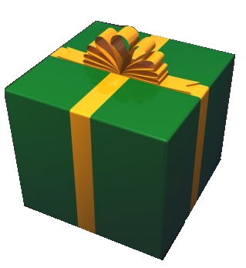

Ex 2: Find the volume of each of the following.

|  |  |
| --- | --- |
| **a.** Right Triangular Prism | **b.**  Right Cylinder |

Ex 4: Find the volume of the oblique cylinder when *h*=12m and *r*=9 m.



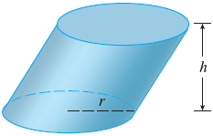

Ex 5: A cistern is a large tank used to collect rainwater. It is made of concrete that is 3 inches thick and is open at the top. Find the volume of the concrete needed to make the sides and bottom of the cistern. (Round you answer to the nearest hundredths)



18 in

20 in

3 in (height of base)

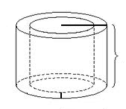

|  |  |
| --- | --- |
| Section: | **11 – 7 Volume of Pyramids and Cones** |
| Essential Question | How do you find the volume of a pyramid or cone? |

Warm Up:

|  |
| --- |
|  |

Key Vocab:

|  |  |  |
| --- | --- | --- |
| Pyramid | A polyhedron in which the base is a polygon and the lateral faces are triangles with a common vertex, called the vertex of the pyramid. | Vertex    *h*  Base  Lateral Face  Lateral edge |
| Volume of a Pyramid | ,  where *B* is the area of the base and *h* is the height. |
| Cone | A solid that has one circular base and a vertex that is not in the same plane as the base. | Vertex  Base |
| Volume of a Cone | where *B* is the area of the base, *h* is the height, and *r* is the radius of the base. |

Show:

Ex 1: Find the volume of each solid. (Round answers to the nearest hundredths)

|  |  |
| --- | --- |
| a.) Find the volume of the *square pyramid.* | b.) Find the volume of the *skew cone.* |

Ex 2: The Pyramid of the Sun in Teotihuacan, Mexico, is a regular square pyramid with height 63m and volume 970,725 . Find the side length of the base.



Ex 3: Find the volume of the right cone. (Round your answer to two decimal places)

 

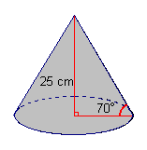

Ex 4: Find the volume of the solid shown which is formed by two cones. (Round your answer to two decimal places)



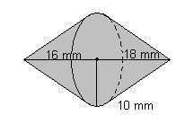

|  |  |
| --- | --- |
| Section: | **11 – 8 Surface Area and Volume of Spheres** |
| Essential Question | How do you find the volume of a sphere? |

Warm Up:

|  |
| --- |
|  |

Key Vocab:

|  |  |  |
| --- | --- | --- |
| Sphere | The set of all points in space equidistant from a given point called the center of the sphere. |  |
| Volume of a Sphere | ,  where *r* is the radius of the sphere. |
| Surface Area of a Sphere | ,  where *r* is the radius of the sphere. |
| Great Circle | The intersection of a sphere and a plane that contains the center of the sphere. | |
| Hemisphere | Half of a sphere formed when a great circle separates a sphere into two congruent halves. | |

Show:

Ex 1: Find the *surface area* of the sphere with a radius of 12 ft.



Ex 2: **Multiple Choice:** The surface area of a sphere is. What is the *diameter* of the sphere?

|  |  |
| --- | --- |
| **A.** | **C.** |
|  |  |
| **B.** | **D.** |

Ex 3: A globe of Earth is a model of a sphere. The circumference of this globe is . Find the surface area of the globe.

 

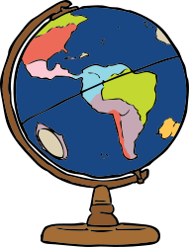

Ex 4: This beach ball has a diameter of 15 inches. Find its volume.

 

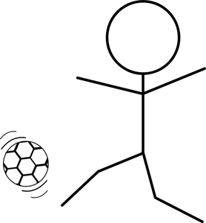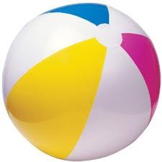

Ex 5: Find the volume of the solid created by a cylinder ad two hemispheres.



