***Chapter 3*** – Parallel and Perpendicular Lines

In this chapter we address three Big IDEAS:

1. **Using properties of parallel and perpendicular lines**
2. **Proving relationships using angle measures**
3. **Making connections to lines in algebra**

|  |  |
| --- | --- |
| Section: | **3 – 1 Identify Pairs of Lines and Angles** |
| Essential Question | **What angles pairs are formed by two lines and a transversal?** |

Warm Up:

|  |
| --- |
|  |



Key Vocab:

|  |  |  |
| --- | --- | --- |
| Parallel Lines | Two lines that do not intersect and are coplanar |  |
| Skew Lines | Lines that do not intersect and are NOT coplanar |  |
| Parallel Planes | Two planes that do not intersect |  |
| Transversal | A line that intersects two or more coplanar lines at different points | line *t* is a transversal |
| Corresponding Angles | Two angles that are formed by two lines and a transversal and occupy corresponding positions | are  corresponding angles |
| Alternate Interior Angles | Two angles that are formed by two lines and a transversal and lie between the two lines and on opposite sides of the transversal. | are  interior angles |
| Alternate Exterior Angles | Two angles that are formed by two lines and a transversal and lie outside the two lines and on opposite sides of the transversal. | are  Alternate exterior angles |
| Consecutive Interior Angles | Two angles that are formed by two lines and a transversal and lie between the two lines and on the same side of the transversal.  Also called *same-side interior angles*. | are  consecutive interior angles |

Postulates:

|  |  |
| --- | --- |
| **Parallel Postulate** | |
| **If**  there is a line and a point not on the line, | **Then**  there is exactly one line through the point parallel to the given line. |
|  |  |

|  |  |
| --- | --- |
| **Perpendicular Postulate** | |
| **If**  there is a line and a point not on the line, | **Then**  there is exactly one line through the point perpendicular to the given line. |
|  |  |

Show:

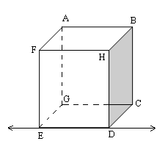Ex 1**:** Think of each segment in the figure as part of a line. Which line(s) or plane(s) appear to fit the description?

1. Line(s) parallel to  and containing point C. 
2. Line(s) skew to. , , , 
3. Line(s) perpendicular to . , , , 
4. Plane(s) parallel to plane ABH. plane *CDE*

Ex 2:The figure shows a sing set on a playground.

|  |  |
| --- | --- |
|  | 1. Name a pair of perpendicular lines. Sample Answers: , , , |
| 1. Name a pair of parallel lines. Sample Answer: ,   , |
| 1. Is perpendicular to ? Explain. No, the lines are skew. |

Ex 3:Identify all pairs of angles of the given type.

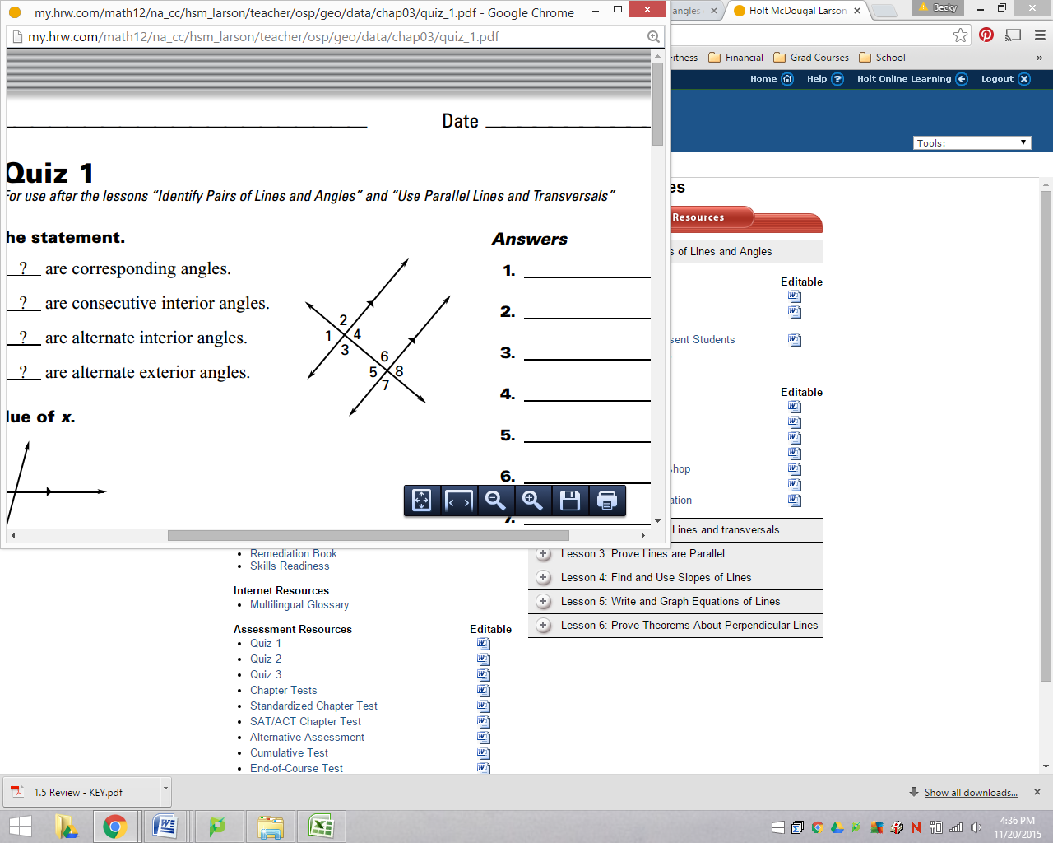a. Corresponding <1 and <5; <2 and <6;

<3 and <7; <4 and <8.

b. Alternate interior <3 and <6; <4 and <5

c. Alternate exterior <1 and <8; <2 and <7

d. Consecutive interior <3 and <5; <4 and <6

Closure:

* What angle pairs are formed by two lines and a transversal?

Angle pairs formed by three intersecting lines include corresponding, alternate interior, consecutive interior, and alternate exterior angles.

|  |  |
| --- | --- |
| Section: | **3– 2 Use Parallel Lines and Transversals** |
| Essential Question | How are corresponding angle pairs and alternate interior angle pairs related when two parallel lines are cut by a transversal? |

Warm Up:

|  |
| --- |
|  |

Postulates and Theorems:

|  |  |
| --- | --- |
| **Corresponding Angles Postulate** | |
| **If**  two parallel lines are cut by a transversal, | **Then**  the pairs of corresponding angles are congruent. |
|  |  |
| *l*  *m* | *l*  *m* |

|  |  |
| --- | --- |
| **Alternate Interior Angles Theorem** | |
| **If**  two parallel lines are cut by a transversal, | **Then**  the pairs of alternate interior angles are congruent. |
|  |  |
| *l*  *m* | *l*  *m* |

|  |  |
| --- | --- |
| **Alternate Exterior Angles Theorem** | |
| **If**  two parallel lines are cut by a transversal, | **then**  the pairs of alternate exterior angles are congruent. |
|  |  |
| *l*  *m* | *l*  *m* |

|  |  |
| --- | --- |
| **Consecutive Interior Angles Theorem** | |
| **If**  two parallel lines are cut by a transversal, | **then**  the pairs of consecutive interior angles are supplementary. |
|  |  |
| *l*  *m* | *l*  *m* |

Show:

|  |  |
| --- | --- |
| Ex 1: The measure of three of the numbered angles is 55o. Identify the angles. Explain your reasoning. | |
|  | ***If*** the lines are parallel:  Corresponding Angles Postulate; by the Vertical Angles Congruence Theorem. |

Ex 2: Find the value of x. 165 by the Corresponding Angles Postulate

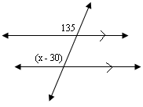

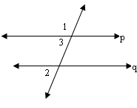Ex 3: Prove that *if two parallel lines are cut by a transversal, then the exterior angles on the same side of the transversal are supplementary*.

Given:

Prove: 

|  |  |
| --- | --- |
| **Steps** | **Reasons** |
|  | 1. Given |
|  | 1. Linear Pair Post. |
|  | 1. Corresponding Ang’s Post. |
|  | 1. Def of Cong Ang’s |
|  | 1. Substitution |
|  | 1. Def. of Supplementary Ang’s |

Try:

Ex 4: Prove the Alternate Interior Angles Theorem: *if two parallel lines are cut by a transversal, then the alternate interior angles are congruent*.



2

Given:

3

Prove: 

|  |  |
| --- | --- |
| **Steps** | **Reasons** |
|  | 1. Given |
|  | 1. Vert. Ang’s Congr. Thm. |
|  | 1. Corresponding Ang’s Post. |
|  | 1. Transitive Prop. |
|  |  |
|  |  |

Closure:

* When are pairs of corresponding, alternate interior, and alternate exterior angles congruent?

Pairs of corresponding, alternate interior, and alternate exterior angles are congruent **only when two parallel lines are cut by a transversal**

* When are consecutive interior angles supplementary?

Consecutive interior angles are supplementary **only when two parallel lines are cut by a transversal.**

|  |  |
| --- | --- |
| Section: | **3 – 3 Prove Lines are Parallel** |
| Essential Question | How do you prove that lines are parallel? |

Warm Up:

|  |
| --- |
|  |

Key Vocab:

|  |  |
| --- | --- |
| Paragraph Proof | A type of proof written in paragraph form |

Postulates and Theorems:

|  |  |
| --- | --- |
| **Corresponding Angles Postulate Converse** | |
| **IF**  two lines are cut by a transversal so the corresponding angles are congruent, | **then**  the lines are parallel. |
|  |  |
| *l*  *m* | *l*  *m* |

|  |  |
| --- | --- |
| **Alternate Interior Angles Theorem Converse** | |
| **If**  two lines are cut by a transversal so the alternate interior angles are congruent | **then**  the lines are parallel. |
|  |  |
| *l*  *m* | *l*  *m* |

|  |  |
| --- | --- |
| **Alternate Exterior Angles Theorem Converse** | |
| **If**  two lines are cut by a transversal so the alternate exterior angles are congruent | **then**  the lines are parallel. |
|  |  |
| *l*  *m* | *l*  *m* |

|  |  |
| --- | --- |
| **Consecutive Interior Angles Theorem Converse** | |
| **If**  two lines are cut by a transversal so the consecutive interior angles are supplementary | **then**  the lines are parallel. |
|  |  |
| *l*  *m* | *l*  *m* |

|  |  |  |
| --- | --- | --- |
| **Transitive Property of Parallel Lines** | | |
| **If**  two lines are parallel to the same line, | **then**  they are parallel to each other. | a  b  c  If a||b and b||c, then a||c. |

Show:

Ex 1: Find the value of *y* that makes *a |*| *b*. 23 by the alternate exterior angles converse

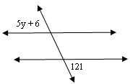

Ex 2: Can you prove that lines *a* and *b* are parallel? Justify your answer.

|  |  |  |
| --- | --- | --- |
| **a. Yes, Alt. Ext. Conv** | **b. Yes, Corr. Conv.** | **c. No** |

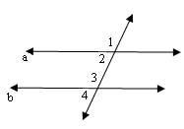Ex 3: Prove that if are supplementary then *a* || *b*.

Given: are supplementary

Prove: *a* || *b*

|  |  |
| --- | --- |
| **Steps** | **Reasons** |
| 1. are supplementary | 1. Given |
|  | 1. Def of Supplementary Ang’s |
|  | 1. Linear Pair Post. |
|  | 1. Add. Prop. Of Eq |
|  | 1. Commutative Prop. Of Eq |
|  | 1. Substitution |
|  | 1. Subtr Prop. Of Eq |
| 1. a || b | 1. Consec Int Ang’s Converse |

Ex 4: Prove the Alternate Interior Angles Theorem Converse in two-column form.

2

Given: 

Prove: *a* || *b*

|  |  |
| --- | --- |
| **Steps** | **Reasons** |
|  | 1. Given |
|  | 1. Vert. Theorem |
|  | 1. Transitive Property |
|  | 1. Corr. Postulate Converse |

Ex 5: Prove the Alternate Interior Angles Theorem Converse in paragraph form.



2

2

Given: 

Prove: *a* || *b*

Angles 1 and 2 are vertical angles, and by the vertical angles congruence theorem, congruent. Since we know that , we can use the transitive property to show. Finally, because these two angles are corresponding, we can use the corresponding angles postulate converse to show a || b.

|  |
| --- |
|  |
|  |
|  |
|  |
|  |
|  |
|  |
|  |
|  |
|  |
|  |
|  |
|  |

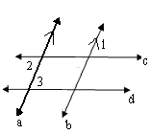Ex 6: Write a paragraph proof.

Given: *a* || *b*; .

Prove *c* || *d*.

It is given that a || b, so  by Alternate Exterior Angle Theorem. Since , it follows that  by Transitive Property of Congruence. Therefore, c || d by the Alternate Interior Angles Converse.

|  |
| --- |
|  |
|  |
|  |
|  |
|  |
|  |
|  |
|  |
|  |
|  |
|  |
|  |
|  |

Closure:

* What does the Corresponding Angles Postulate prove? What do you need to know in order to use this postulate?

The Corresponding Angles Postulate proves that when you have parallel lines, pairs of corresponding angles are congruent. In order to use the Corresponding Angles Postulate, you need to know that two lines are parallel.

* What does the Corresponding Angles Postulate Converse say? What do you need to know in order to use Corresponding Angles Postulate Converse?

The Corresponding Angles Postulate Converse says that when you have congruent corresponding angles, the lines creating them must be parallel. In order to use this postulate, you must know that a pair of corresponding angles is congruent.

* Name FIVE ways to prove that lines are parallel*.*
  1. The Corresponding Angles Postulate **Converse**
  2. The Alternate Interior Angles Theorem **Converse**
  3. The Alternate Exterior Angles Theorem **Converse**
  4. The Consecutive Interior Angle Theorem **Converse**
  5. The Transitive Property of Parallel Lines

|  |  |
| --- | --- |
| Section: | **3 – 4 Find and use Slope of Lines** |
| Essential Question | How do you find the slope of a line given the coordinates of two points on the line? |

Warm Up:

|  |
| --- |
|  |



Key Vocab:

|  |  |  |
| --- | --- | --- |
| S l o p e | | |
| The slope *m* of a nonvertical line is the ratio of the vertical change (the *rise*) to the horizontal change (the *run*) between any two points on the line | |  |
| Positive Slope  Uphill | Negative Slope  Downhill | |
| Special Cases | | |
| Vertical Lines  Undefined or No Slope | Horizontal Lines  Zero Slope | |

|  |  |
| --- | --- |
| Slopes of Parallel Lines | |
| In a coordinate plane, two non-vertical lines are parallel if and only if they have the same slope.  Any two vertical lines are parallel. | ANd9GcT7R1UyvlrZRqyNn_iGdJ9ga_6AhXh1nmYgECWvikSTEoAqgs56Tw  *m*1 = *m*2 |

|  |  |
| --- | --- |
| Slopes of Perpendicular Lines | |
| In a coordinate plane, two non-vertical lines are perpendicular if and only if the product of their slopes is -1.  Parallel and perpendicular slopes will be *negative reciprocals.*  Horizontal lines are perpendicular to vertical lines. | ANd9GcS46PiEwUNAG9nMYTghjmo_pcDngu_kjabphvk1ePMhOU4XPyAd  *m*1(*m*2) = -1 |

Show:

|  |  |
| --- | --- |
| Ex 1: Find the slope of each line. Which lines are parallel? | Ex 2: Find the indicated slope.  **a.)** the line containing points (0, 3) and (5, 2)    **b.)** the line perpendicular to the line containing (0, 3) and (5, 2)    **c.)** the line parallel to the line containing  (0, 3) and (5, 2) |

Ex 3: The population of a small town was 32,150 in 1990. A census in 2002 showed that the population was 22,550. Find the *average rate of change* in population per year from 1990 to 2002. Assuming this rate remains constant, what should the population be in 2003?





Ex 4: A candle is lit at the center of the table at the beginning of a dinner party. Its height decreases by 1.75 inches every 25 minutes. At the beginning of the dinner, the candle was 8 inches tall.

1. Make a table showing the height of the candle at 25 minute intervals.

|  |  |  |  |  |
| --- | --- | --- | --- | --- |
| Time (min) | 0 | 25 | 50 | 75 |
| Height (in) | 8 | 6.25 | 4.5 | 2.75 |

1. Write a fraction that represents the decrease in height for each minute the candle burns. What does the numerator represent?

; the height of the candle.

Closure:

* What is the slope of a vertical line?

Vertical lines have undefined or no slope.

* What is the slope of a horizontal line?

Horizontal lines have zero slope.

|  |  |
| --- | --- |
| Section: | **3– 5 Write and Graph Equations of Lines** |
| Essential Question | How do you write an equation of a line? |

Warm Up:

|  |
| --- |
|  |

Key Vocab:

|  |  |
| --- | --- |
| Slope-intercept Form | A linear equation written in the form ***y = mx + b*** where *m* is the slope and *b* is the y-intercept.  🡪Best form for graphing. |
| Standard form | A linear equation written in the form ***Ax + By = C***, where *A*, *B* and *C* are integers and *A* and *B* are not both zero. |
| Point-slope Form | A linear equation written in the form , where *m* is the slope and is a coordinate. |
| Vertical Line | where *a* is the *x*-intercept  Vertical lines have undefined or no slope |
| Horizontal Line | where *b* is the *y*-intercept  Horizontal lines have zero slope |

Show:

|  |  |
| --- | --- |
| Ex 1: Write an equation of the line in slope-intercept form. *y* = 4*x* - 3  GRID3 | Ex 2: Graph 2x – 3y = -12.  GRID3 |

Ex 3: The graph shows the cost of having cable television installed in your home. Write an equation of the line. Explain the meaning of the slope and the y-intercept of the line.

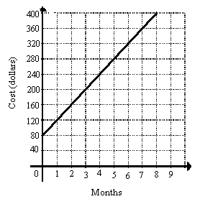

*y* = 40*x* + 80

The slope is the cost per month , and the *y*-intercept is the initial cost.

You will need to pay an initial cost of $80 and then an additional $40 per month afterward.

Ex 4: Write an equation of the line passing through the point (2, -3) that is parallel to the line with the equation *y* = 6*x* + 4.





Point-Slope Form

Slope-Intercept Form

Standard Form



Try:

Ex 5: Write an equation of the line a passing through the point (3, -4) that is perpendicular to the line with the equation *y* = -½*x* – 1.



Point-Slope Form

Slope-Intercept Form

Standard Form





Closure:

* What are the FIVE forms of a linear equation?
  1. Standard Form: 
  2. Slope-Intercept Form: 
  3. Point-Slope Form: 
  4. Vertical Line: 
  5. Horizontal Line: 

|  |  |
| --- | --- |
| Section: | **3 – 6 Prove Theorems about Perpendicular Lines** |
| Essential Question | How do you find the distance between a point and a line? |

Warm Up:

|  |
| --- |
|  |

Key Vocab:

|  |  |  |
| --- | --- | --- |
| Distance from a Point to a Line | The length of the perpendicular segment from a point to a line. |  |

Theorems:

|  |  |  |
| --- | --- | --- |
| **If**  two lines intersect to form a linear pair of congruent angles, | **Then**  the lines are perpendicular. | If , then |
| **If**  two sides of two adjacent acute angles are perpendicular, | **Then**  the angles are complementary. | If are complementary. |

|  |  |
| --- | --- |
| **Perpendicular Transversal Theorem**: | |
| **If**  a transversal is perpendicular to one of two parallel lines, | **Then**  it is perpendicular to the other. |
| and |  |
|  |  |

|  |  |
| --- | --- |
| **Lines Perpendicular to a Transversal Theorem:** | |
| **In a plane, if**  two lines are perpendicular to the same line, | **Then**  they are parallel to each other. |
|  |  |
|  |  |

Show:

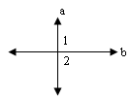Ex 1: In the figure, are congruent. What can you conclude about ?



Ex 2: Determine which other lines, if any, must be perpendicular. Explain your reasoning.

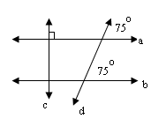

By the Corr. Angles Post Conv.,.

So,  Perp. Transversal Theorem

Ex 3: Is ? Is ? Explain your reasoning.

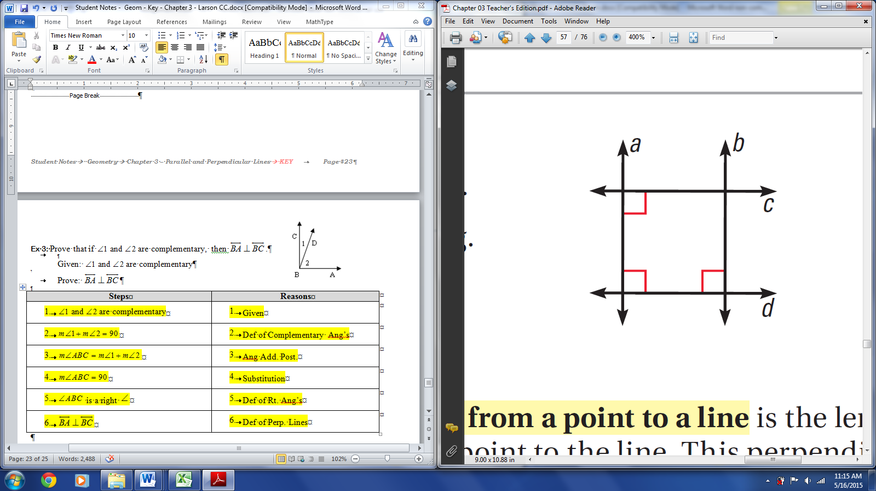

Yes,  by the Lines Perpendicular to a Transversal Theorem

Yes,:  by the Lines Perpendicular to a Transversal Theorem, so  by the Perpendicular Transversal Theorem

Ex 4: Prove the Perpendicular Transversal Theorem

1

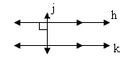

2

Given: ;

Prove: 

|  |  |
| --- | --- |
| **Steps** | **Reasons** |
| 1. ; | 1. Given |
|  | 1. Def of Perp. Lines |
|  | 1. Alt. Int. Angles Thm |
|  | 1. Def. of Congr. Ang’s |
|  | 1. Def of Rt. Ang’s |
|  | 1. Def of Perp. Lines |

Ex 5: What is the distance between the two parallel sides of this table top?

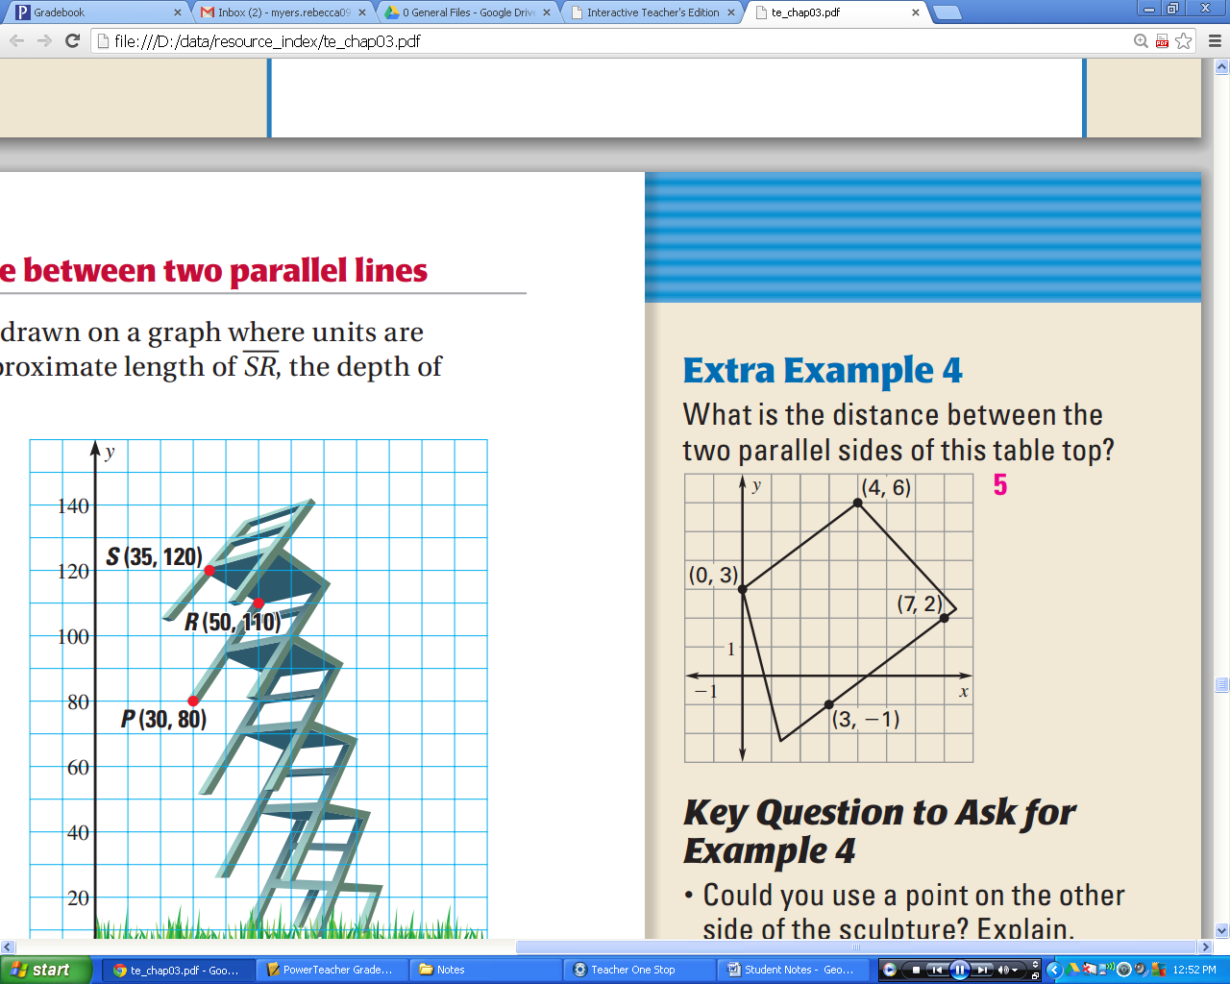

**Graphical Method:**

 

Algebraic Method:

|  |  |
| --- | --- |
|  | **3.**    **4.** |

Closure:

* Compare and contrast the Perpendicular Transversal Theorem and the Lines Perpendicular to a Transversal Theorem.

The Perpendicular Transversal Theorem is used to prove that two lines are perpendicular, while the Lines Perpendicular to a Transversal Theorem is used to prove that two lines are parallel.

The Perpendicular Transversal Theorem requires one line to be perpendicular to one of two parallel lines, whereas the Lines Perpendicular to a Transversal Theorem requires two lines to be perpendicular to the same line.

* Summarize the method for algebraically finding the distance between two lines
  1. Find the slope of the parallel lines🡪**Find the slope of a perpendicular line**.
  2. **Find the equation of a perpendicular line**. (Use the perpendicular slope and choose a point on one of the two parallel lines)
  3. Use a system of equations to **find the intersection** of the perpendicular line and the second parallel line. (set the first parallel equation equal to the perpendicular equation then solve for *x* and *y*.)
  4. **Use the distance formula** to find the distance. (plug the chosen point and the intersection point into the distance formula)