**Ch 1 Points, Lines, Planes and Angles**

**Undefined Terms**

1) Point:

2) Line:

3) Plane:

**Defined Terms**

1) Line Segment:

2) Ray:

3) Opposite Rays:

**Symbolism**

$\overset{⃡}{AB}$

$\overline{AB}$

$\vec{AB}$

$AB$

$∠ABC$

$m∠ABC$

**Midpoint/Segment Bisector**

Point M is called the ___________ of the segment.

Line k is called the segment _____________

**______________ Points**

Lie in the same line

**____________ Points**

Lie in the same plane

**Segment Addition Postulate:**

**Angle Addition Postulate:**

**Vertical Angles:**

**Supplementary Angles:**

**Complementary Angles:**

**Congruent Angles:**

**Linear Pair:**

**Adjacent Angles:**

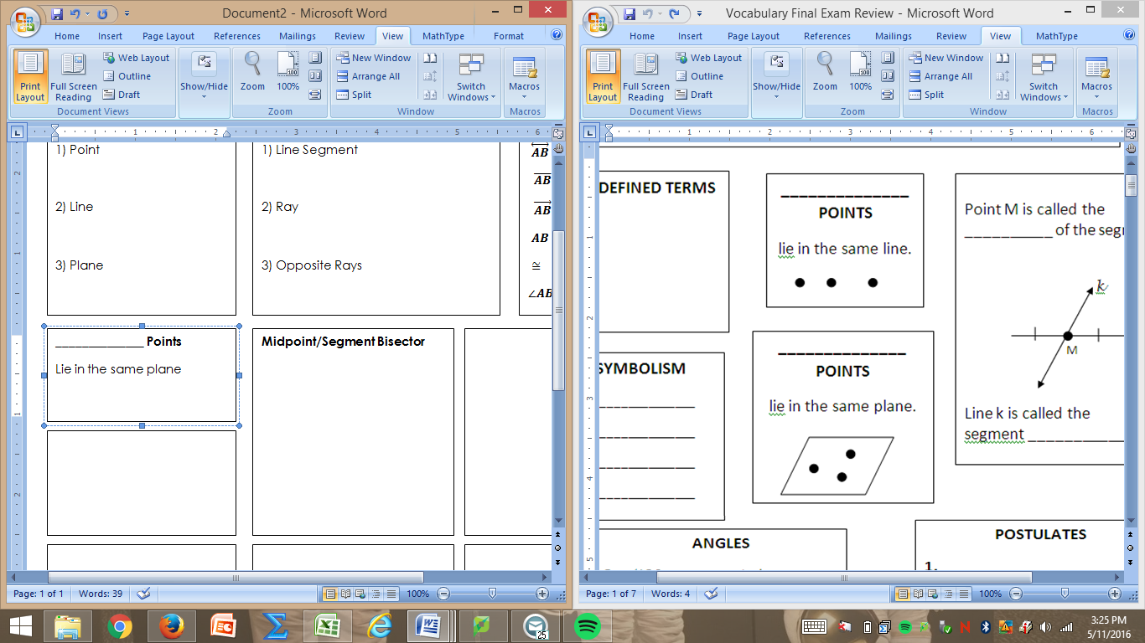

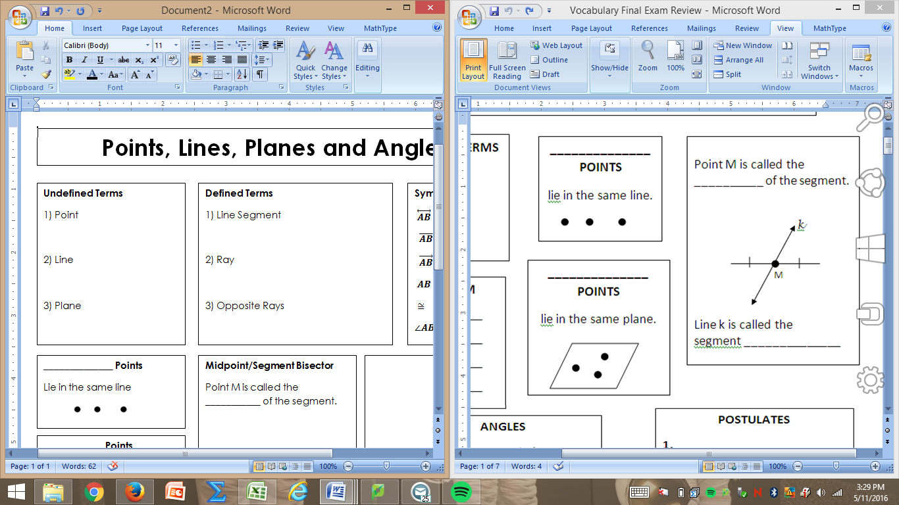

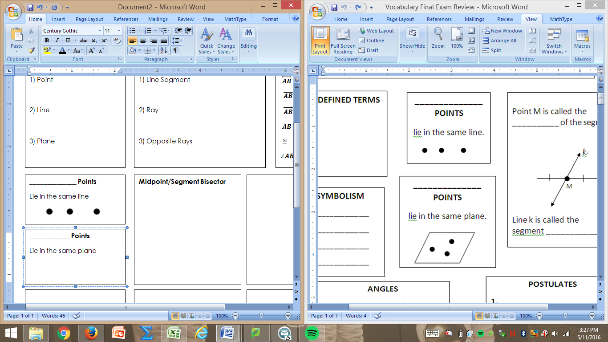

**Ch 2 Reasoning and Proof**

**Conditional Statement:**

**Converse:**

**Inverse:**

**Contrapositive:**

**Bi-conditional Statement:**

**Point, Line and Plane Postulates:**

**1)**

**2)**

**3)**

**4)**

**5)**

**6)**

**7)**

**Reflexive Property of eq.**

**Symmetric Prop. of eq.**

**Transitive Prop of eq.**

**Right Angles ≅ Thm**

**Reflexive Property of ≅**

**Symmetric Prop. of ≅**

**Transitive Prop of ≅**

**Vertical Angles ≅ Thm**

**Congruent Supplements Thm.**

**Cong. Complements Thm.**

**Linear Pair Postulate**

**Ch 3 Parallel and Perpendicular Lines**

**Parallel Lines**

Symbol _____

Two lines that do not _______________ and are _____________

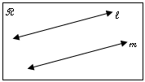

Line t is called the __________________

∠1 and ∠5 are _________________ angles.

∠3 and ∠6 are _____________ interior angles.

∠2 and ∠7 are _____________ exterior angles.

∠4 and ∠6 are _____________ interior angles.

**Perpendicular Lines**

Symbol _____

Two lines that intersect to form four _________ angles

**Skew Lines**

Lines that do not ___________ and are NOT _____________

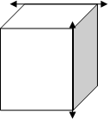

**Parallel Planes**

Two planes that do not _______________

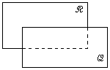

If two **parallel** lines are cut by a transversal:

1. _________________ interior, _________________ exterior and _________________ angles are congruent.
2. _________________ interior angles are supplementary.

**Methods to prove that two lines are parallel:**

1) Prove alt. interior angles are ______________

2) Prove alt. exterior angles are _____________.

3) Prove corresponding angles are ___________.

4) Prove Cons. Interior angles are _____________.

**Slope:**

**Horizontal Slope:**

**Vertical Slope:**

**Slope-Intercept form:**

**Standard form:**

**Point- Slope form:**

**Vertical Line:**

**Horizontal Line:**

**Writing an equation parallel to given line:**

**Writing an equation perpendicular to given line:**

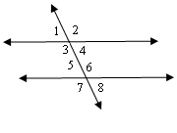

$$t$$

**Ch 4 Congruent Triangles**

**Types of Triangles by Sides**

Scalene:

Isosceles:

Equilateral:

**Δ Sum Thm.**

**Types of Triangles by Angles**

Acute:

Right:

Obtuse:

Equiangular:

**Methods to prove that two triangles are congruent (Draw a picture for each)**

1)______ ≅ 2)______≅

3)______≅ 4)______≅

5) ______≅

**Ext Angle Thm.**



**IS FOLLOWED BY**

CPCTC means

**Components of an Isosceles Triangle**

_______: The congruent sides.

_________ _______: The angle formed by the legs.

________: The third side (not a leg)

______ _________: The two angles adjacent to the base.

**Base Angles Theorem**

**Base Angles Theorem Converse:**

If a triangle is equilateral, then it is ___________________.

If a triangle is equiangular, then it is ___________________.

Each angle in an equiangular triangle measures ________.

**Ch 5 Relationships within Triangles**

**Mid-segment theorem**

The segments connecting the midpoints of two sides of a Δ are:

a)

b)

**Points of Concurrency**

The circumcenter is where the _____________ ______________ of a triangle meet.

The incenter is where the ___________ _____________ meet.

The centroid is where the _____________ meet.

The orthocenter is where the _______________ meet.

**Median**

A segment from one __________ of the triangle to the ____________ of the opposite side

**Circumcenter Theorem**: The ________________ ______________ of a triangle meet at a point _________________ from the __________________ of a triangle.

**Incenter Theorem**: The __________ __________ of a triangle meet at a pt that is ____________ from the ________ of a triangle.

**Centroid Theorem**: The _____________ of a triangle meet at a point 2/3 the distance from each vertex to the _____________ of the opposite side.

**Triangle Inequality Theorem**

Given three lengths, a triangle is formed when the sum of any two lengths is ______________ than the third length.

SM + MED > LARGE

**In any triangle…**

The ________ side is across from the largest ∠.

The __________ side is across from the smallest ∠.

**Perpendicular Bisector**

A segment, ray, line or plane that is _______________ to a segment at its _____________.

**Altitude**

The _____________ segment from one ____________ of the triangle to the line that contains the opposite side.

**Hinge Theorem:**

**Hinge Theorem Converse**:

**Ch 6 Similarity**

**Similar Polygons**

Two polygons such that the corresponding angles are ________________

and the corresponding sides are __________________________.

Symbol for Similarity: **______** Similarity Statement: **________________**

**Scale Factor**

**_____________** of corresponding side lengths.

**Methods to prove that two triangles are congruent (Draw a picture/example for each)**

1 )_______~ 2) ______~ 3) ______~

**Perimeter of Similar Polygons Theorem**

If two polygons are similar, then the ratio of their ___________ is equal to the ratios of _______________ ________ __________.



**Ch 7 Right Triangles & Trigonometry**

**Pythagorean Theorem**

___________________ where c is the hypotenuse, and the legs are a and b.

**Geometric Mean Altitude Theorem**

The ___________ is the geometric mean of the two segments of the hypotenuse.

**Converse of the Pythagorean Theorem**

_______________ triangle is formed when $c^{2}<a^{2}+b^{2}$

_______________ triangle is formed when $c^{2}=a^{2}+b^{2}$

______________ triangle is formed when $c^{2}>a^{2}+b^{2}$

**Geometric Mean Leg Theorem**

The ______ is the geometric mean of the hypotenuse and the segment of the hypotenuse adjacent to the leg.

**45°-45°-90° Triangle Theorem**

**30°-60°-90° Triangle Theorem**

**Trig Ratios**

Used to find ___________.

Sin Ɵ= ______

Tan Ɵ= ______

Cos Ɵ=

$S=\frac{O}{H } C=\frac{A}{H} T=\frac{O}{A}$

 _____

**Inverse Trig Ratios**

Used to find ______________.

$θ=\sin^{-1}{(}opp/hyp)$

$θ=\cos^{-1}{(adj/hyp)}$

$θ=\tan^{-1}{(opp/adj)}$

**To solve a right triangle you must find: ALL __________ and ALL ___________**

**Angle of Elevation**

**Angle of Depression**

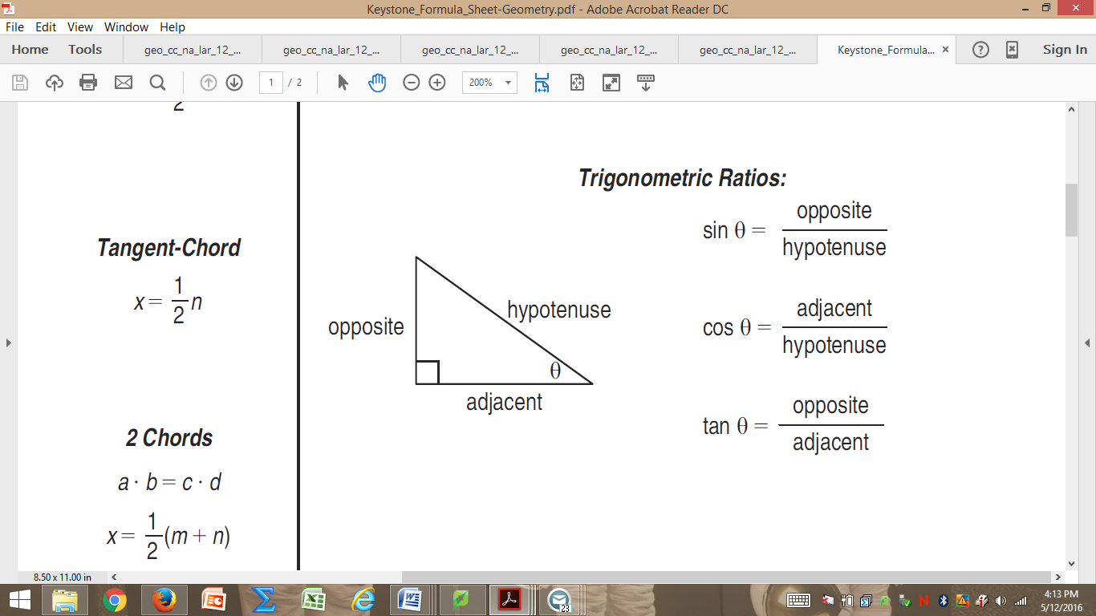

**Ch 8 Polygons & Quadrilaterals**

**__________ 🡪NO OPPOSITE SIDES PARALLEL**

2 pairs of consecutive sides are ≅

One pair of opp. Angles ≅

**ONE SET OF OPPOSITE SIDES PARALLEL**

**1) _________________**

**2) _____________________________**

Pair of ≅ legs and 2 pairs of ≅ base angles.

Diagonals are congruent.

**Polygon Interior Angle Sum Theorem**

**The Polygon EXTERIOR Angle Sum always equals ________.**

**Regular Polygon**

A polygon with all _______ congruent and all ________

congruent.

Example: Stop Sign

Square

**Trap.** **Midseg. Thm**

To find the midsegment add the ______ and then divide by ___.

**BOTH SETS OF OPPOSITE SIDES ARE PARALLEL**

**Parallelogram**

1.Opposite sides are _________________

2. Opposite sides are _________________

3. Opposite angles are _______________

4. Consecutive angles are ____________________

5. Diagonals _____________ each other

**Rectangle**

All properties of a parallelogram plus

1. All angles are _______________

2. Diagonals are _______________

**Rhombus**

All properties of a parallelogram plus

1. All sides are ____________________

2. Diagonals are ___________________

3. Diagonals bisect the _____________________

**Square**

All properties of parallelogram, rhombus, and rectangle.

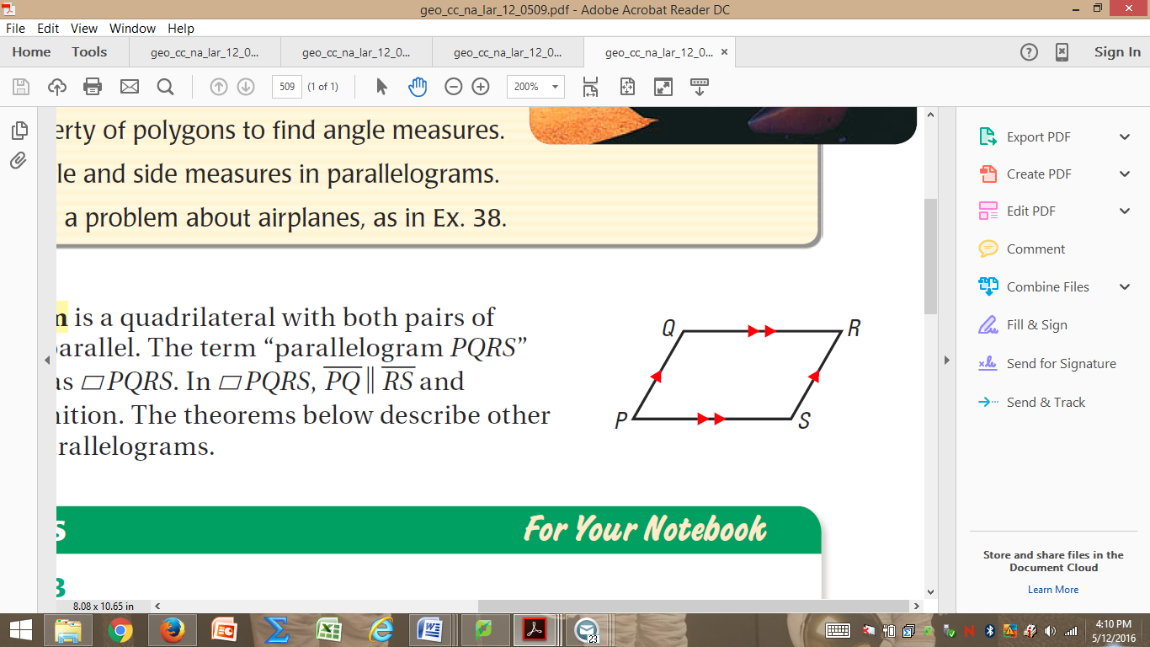

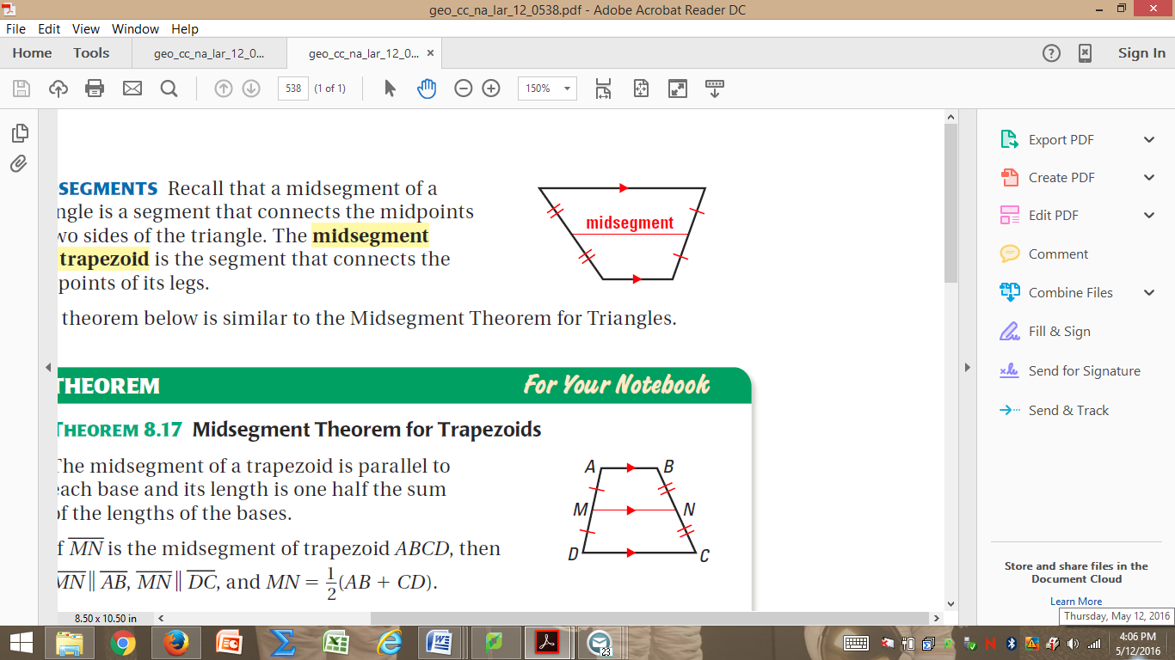

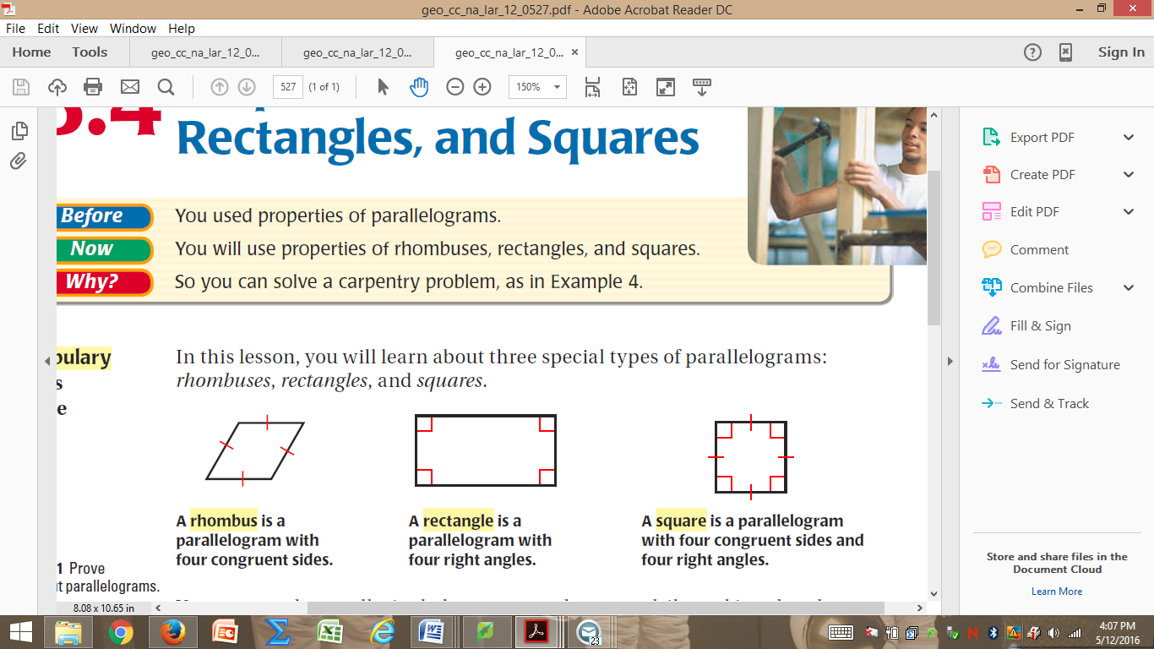

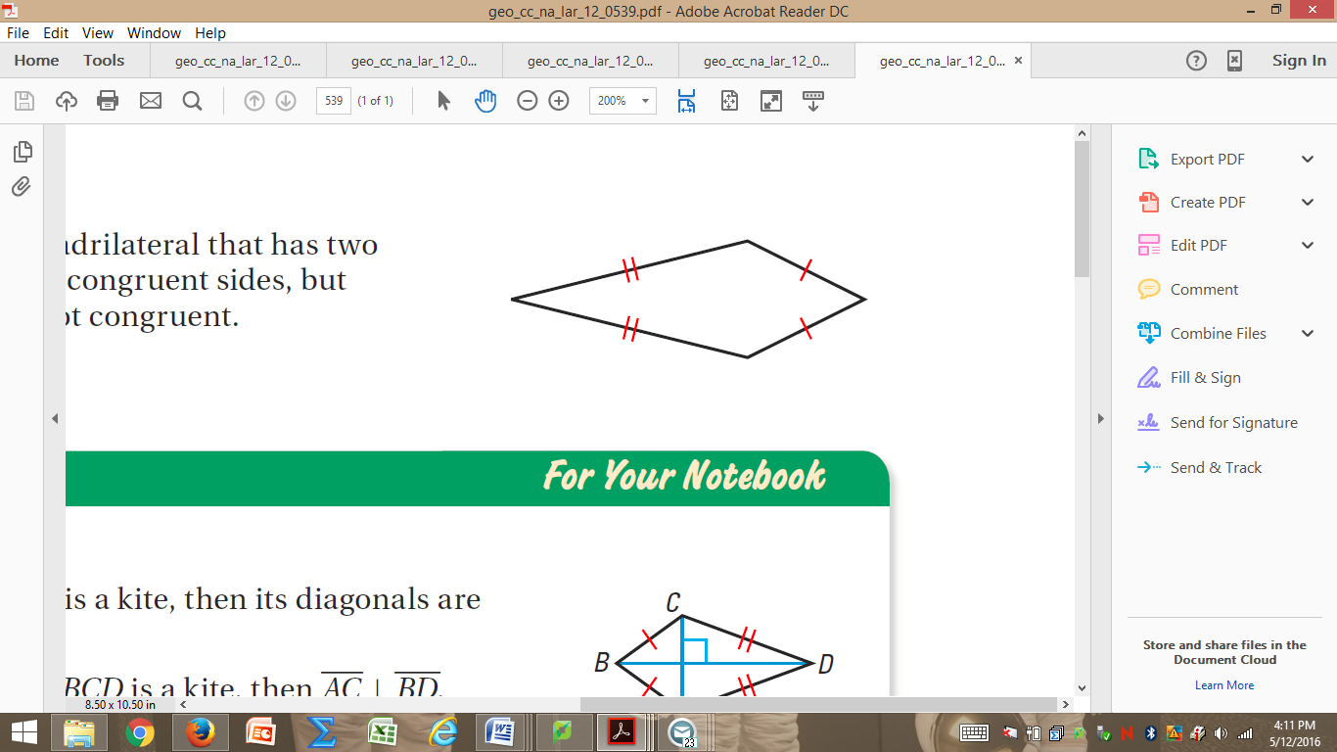



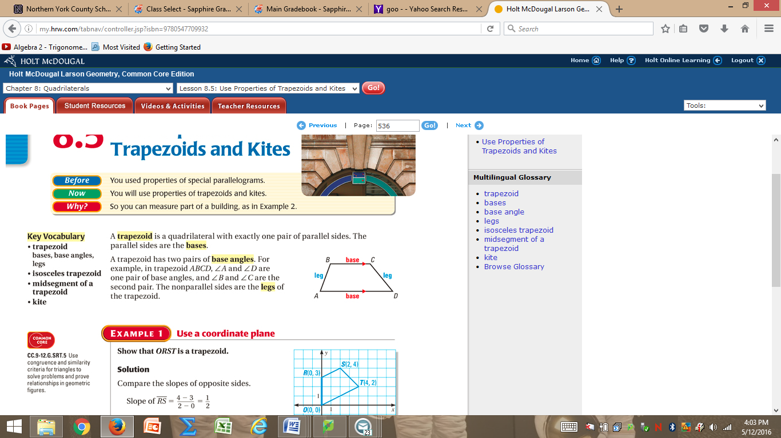

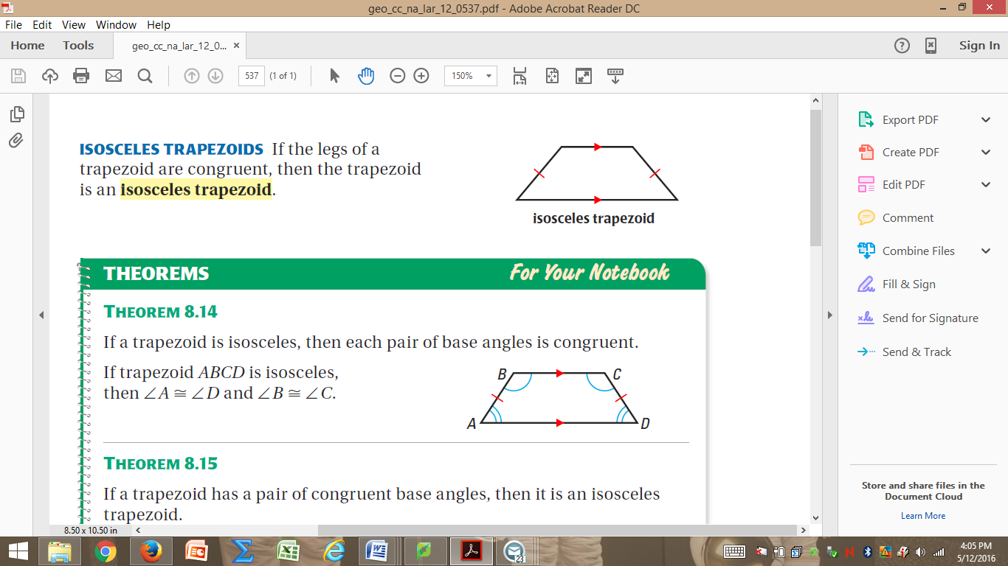

**Ch 10 Circles**

**Parts of a Circle**

Tangent segments from a common external point are _____________.

A line is tangent to a circle IFF the line is _________________ to a radius of a circle at its _______________ on the circle.

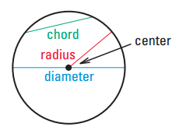

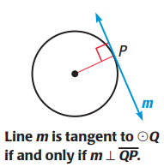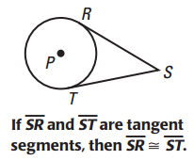

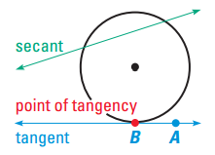

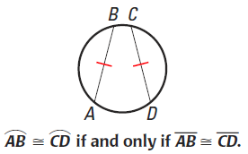

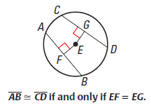

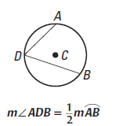

The measure of a minor arc is equal to the measure of the _____________ ____________.

The measure of a major arc is the difference between _____ and the measure of the related minor arc.

The measure of the entire circle is _______.

The measure of a semicircle is _______.

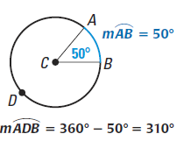

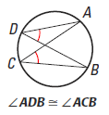

If two inscribed angles of a circle intercept the ______ arc, then the angles are ___________.

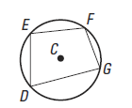

A quadrilateral can be inscribed in a circle IFF its _____________ angles are _________________.

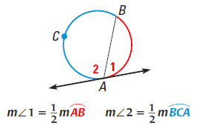

If a tangent and a chord intersect at a point on a circle, then the measure of each angle formed is ________ the measure of its intercepted ________.

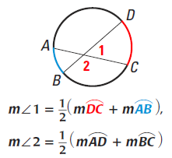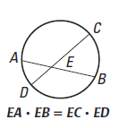

If two chords intersect _________ a circle, the measure of each angle is ______ the sum of the measures of the arcs intercepted by the angle and its ______________ angle.

If a tangent and a secant, two tangents, or two secants intersect ____________ a circle, then the measure of the angle is _________ the _______________ of the measures of the intercepted __________.

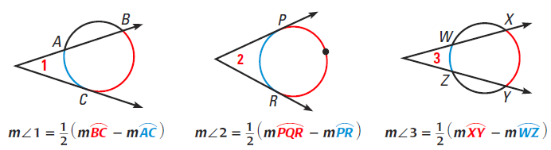

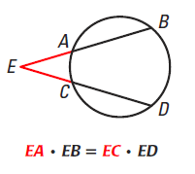

**Standard Equation of a Circle**

The standard equation of a circle with center *(h, k)* and radius *r* is:

______________________________.

