Chapter 5 Crossword

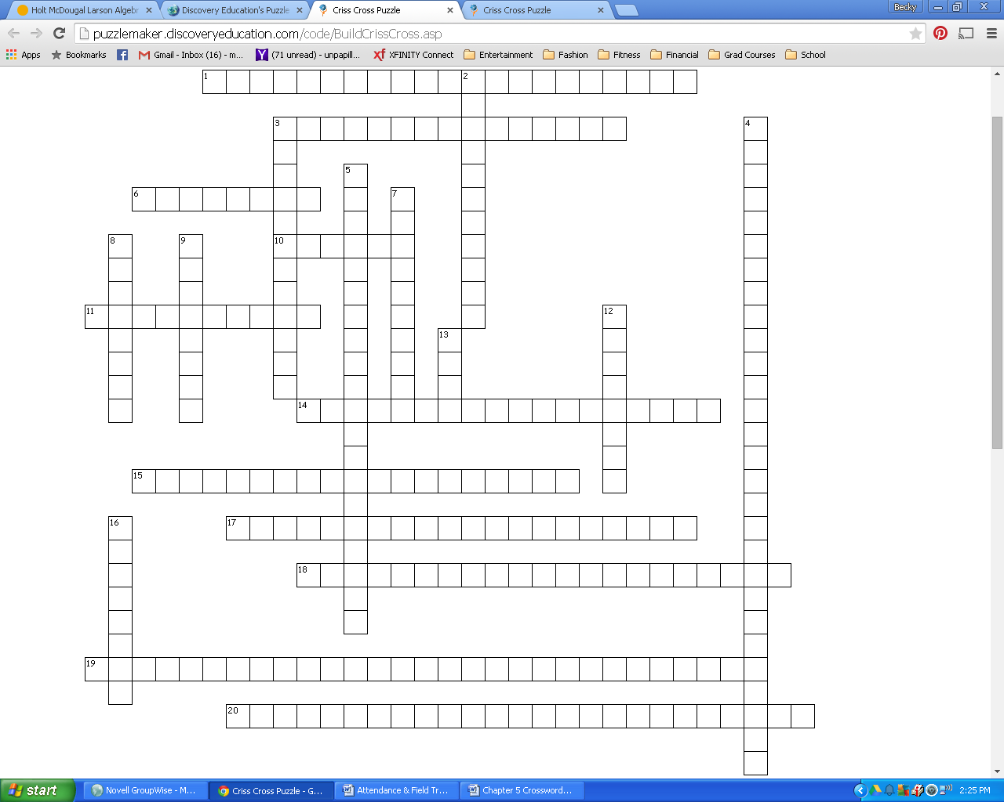

|  |  |
| --- | --- |
| **Across**  **1.** if a point is equidistant from the sides of an , it lies on the bisector of the angle  **3.** the point of concurrency of the medians of a  is 2/3 the distance from the vertex to the midpoint of the opposite side of the  **6.** type of proof that begins by assuming the opposite of the prove statement  **10.** segment in a  that connects the vertex to the midpoint of the opposite side of a  **11.** segment in a  that connects the midpoints of two sides of the  **14.** point of intersection of three or more lines, segments, or rays  **15.** the point of concurrency of the perpendicular bisectors of a is equidistant from the vertices of the  **17.** hinge theorem converse  **18.** line, segment, or ray that intersects a segment at its midpoint AND is perpendicular to that segment | **Across**  **19.** if a point is equidistant from the endpoints of a segment, then it lies on the perpendicular bisector of the segment  **20.** the sum of the lengths of any two sides of a  must be greater than the length of the third  **Down**  **2.** the point of concurrency of the altitudes of a  **3.** the point of concurrency of the perpendicular bisectors of a  **4.** if a point is on the perpendicular bisector of a segment, then it is equidistant from the endpoints of the segment  **5.** hinge theorem  **7.** the altitudes of a  are always _____.  **8.** height of a  **9.** the point of concurrency of the angle bisectors of a  **12.** the point of concurrency of the medians of a  **13.** the length of the midsegment of a  is ____ the length of the third side of the  **16.** the midsegment of a  is _____ to the third side of the |

|  |  |
| --- | --- |
| Across  1. ang bis conv  3. centroid thm  6. indirect  10. median  11. midsegment  14. pt of concur  15. circum thm  17. sss ineq thm  18. perp bis  19. perp bis conv  20. triang ineq thm | Down  2. orthocenter  3. circumcenter  4. perp bis thm  5. sas ineq thm  7. concurrent  8. altitude  9. incenter  12. centroid  13. half  16. parallel |