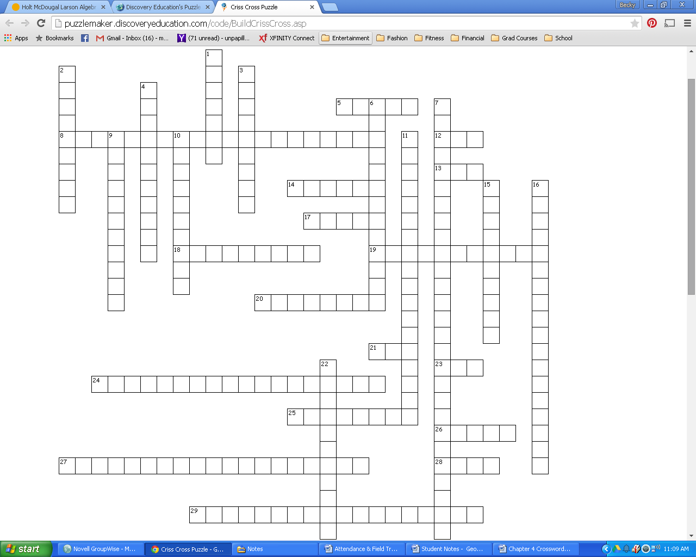Chapter 4 Crossword

|  |  |  |
| --- | --- | --- |
| **Across**  **5.** corresponding parts of congruent triangles are congruent  **8.**  the exterior of a  is equal to the sum of the remote interior two  **12.** method of proving ’s when all pairs of corresponding sides are congruent  **13.** if two ’s and a non-included side of one are to two ’s and a non-included side of another, then the’s are  **14.** a  with a angle  **17.** a  with all ’s measures less than  **18.** a  with at least two  sides  **19.** a transformation that shifts a figure in a fixed direction | **Across**  **20.** rigid motion  **21.** if two ’s and the included side of one  are to two ’s and the included side of another, then the’s are  **23.** if two sides and the included of one  are to two sides and the included of another, then the’s are  **24.** if the base ’s of an isosceles  are , then the sides opposite them are  **25.** to turn an object about a fixed point  **26.** a  with a angle  **27.** if a  is equilateral, then it is equiangular  **28.** the congruent sides in an isosceles  **29.** if two ’s of one  are to two  ’s of another, then the 3rd angles are | **Down**  **1.** a  with no sides  **2.** in a right, if the hypotenuse and a leg of one  is to the hypotenuse and leg of another, then the’s are  **3.** a rule that can be proven by its related theorem  **4.**  all ’s in a  **6.** the acute angles in a right  are ____.  **7.** if a  is equiangular, then it is equilateral  **9.** a with all sides  **10.**  or  **11.** algebraic method of describing transformations  **15.** the longest side in a right  **16.** in a  **22.** the angle between the two sides of an isosceles |