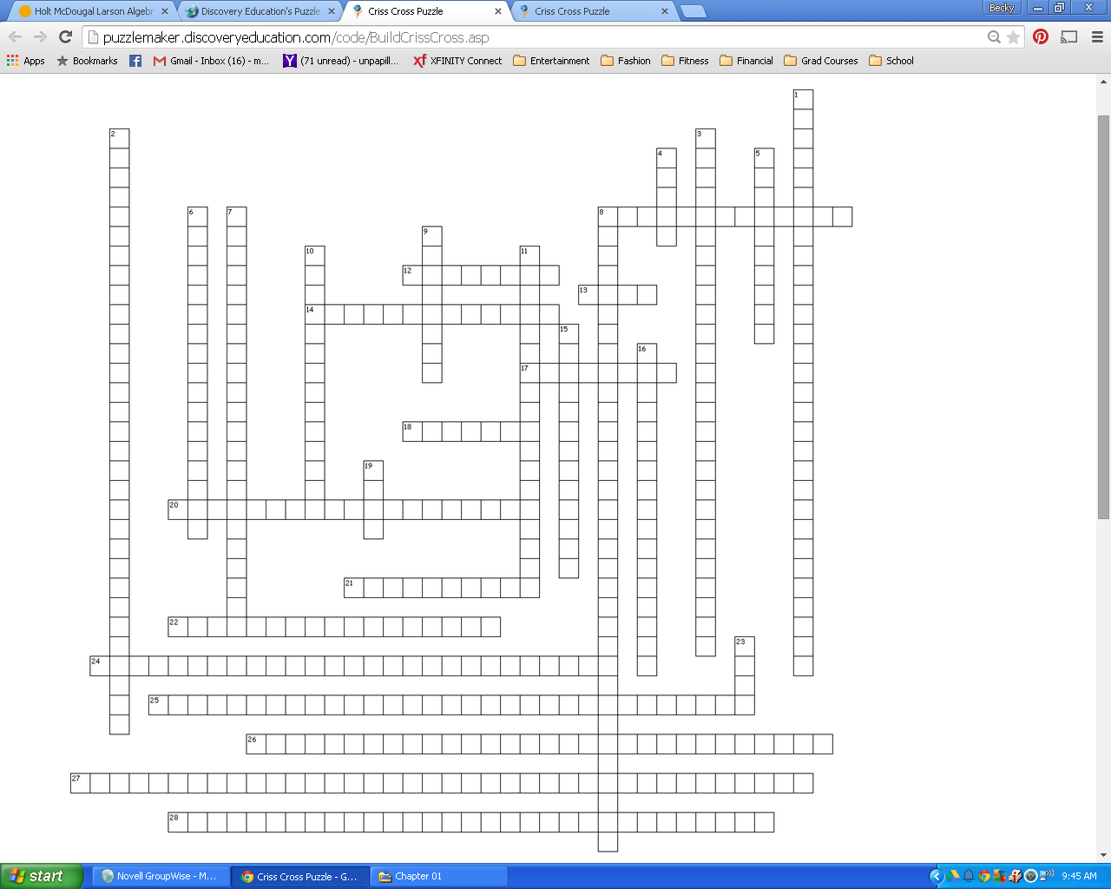





|  |  |  |
| --- | --- | --- |
| **Across**  **8.** If two sides of two adjacent acute angles are , then the angles are _____.  **12.** coplanar lines that do not intersect  **13.** slope of a horizontal line  **14.** in geometry, the distance from a point to a line must be _____.  **17.** line type given by the equation  **18.** undefined slope  **20.** same side interior angles  **21.** line type given by the equation  **22.** angle pair lying outside two lines, but on opposite sides of a transversal  **24.** if corresponding angles are, then the lines creating them must be parallel  **25.** if alternate exterior angles are , then the lines creating them must be parallel. | **Across**  **26.** if parallel lines are cut by a transversal, then the alternate interior angles must be  **27.** if two lines are to the same line, then they are parallel to each other  **28.** if alternate interior angles are , then the lines creating them must be parallel.  **Down**  **1.** if parallel lines are cut by a transversal, then the alternate exterior angles are  **2.** if a transversal is to one of two parallel lines, then it is to the other.  **3.** if parallel lines are cut by a transversal, then the corresponding angles are  **4.** rate of change  **5.** | **Down**  **6.** angle pairs that lie between two lines and on opposite sides of a transversal  **7.** through a point outside a line there is exactly one line perpendicular to that line  **8.** if consecutive interior angles are , then the lines creating them are parallel.  **9.**  **10.**  **11.** perpendicular slopes  **15.** angles that lie in the same relative position  **16.** through a point outside a line there is exactly one line parallel to that line  **19.** noncoplanar lines that do not intersect  **23.** parallel slope |

Across

8. comp

12. parallel

13. zero

14. perp (dist from point to line)

17. vertical

18. no slope

20. consec int

21. horizontal

22. alt ext

24. corr ang conv

25. alt ext conv

26. alt int thm

27. lptt

28. alt int conv

Down

1. alt ext thm

2. perp trans

3. corr ang post

4. slope

5. point slope

6. alt int

7. perp post

8. consec conv

9. standard

10. slope int

11. neg recip

15. corresponding

16. parallel post

19. skew

23. same

