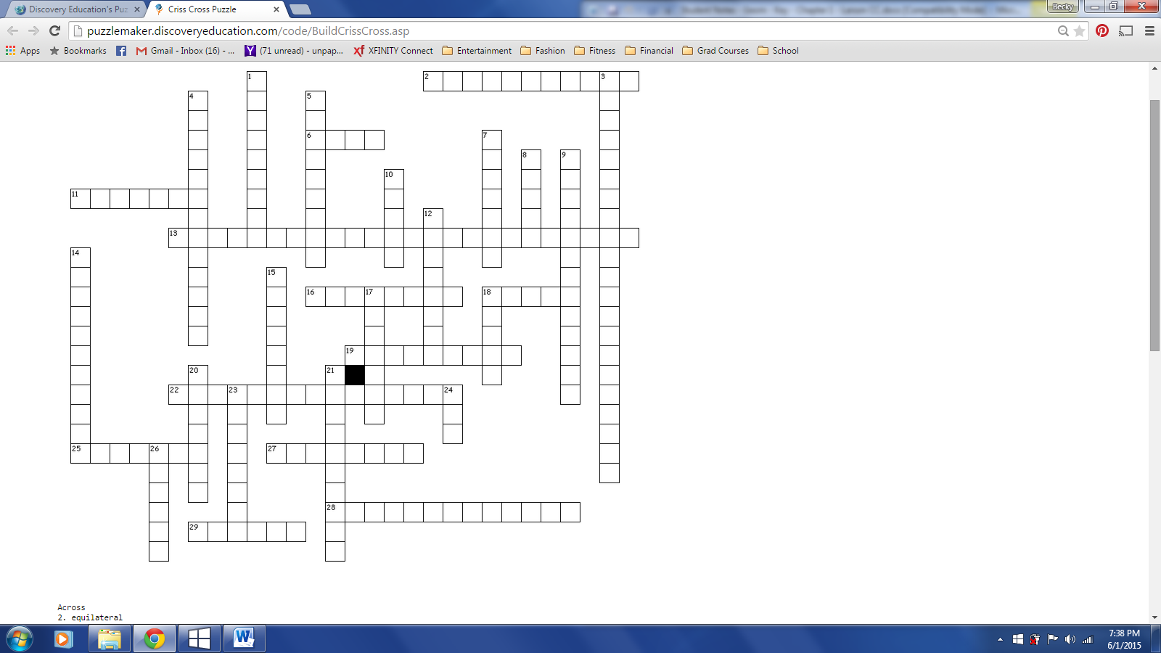

|  |  |
| --- | --- |
| **Across**  **2.** a polygon with all sides congruent  **6.** a figure that extends indefinitely in one dimension  **11.** a polygon that has an interior angles measuring  **13.** “The sum of the parts equals the whole.”  **16.** angle pairs created by intersecting lines  **18.** a figure that extends indefinitely in two dimensions  **19.** two or more figures that have the same size and shape.  **22.** a ray, line, or segment that cuts a segment in half  **25.** the general term for a square root  **27.** an angle that measures  **28.** If , then  is a(n) _______.  **29.** an angle measuring  **Down**  **1.** a rule that does not need to be proven  **3.** the sum of the measure of two smaller angles is equal to one larger angle | **Down**  **4.** two angles whose sum is  **5.** points on the same line  **7.** “many sides”  **8.** an angle whose measure is exactly  **9.** two angles whose sum is  **10.** a small angle  **12.** two or more points in the same plane  **14.** a polygon whose angles are all the same measure  **15.** angles that are right next to each other  **17.** a rule that must be proven  **18.** a figure with no dimension  **20.** a square is a _________ polygon  **21.** two angles whose sum is AND who are adjacent to each other  **23.** a point that cuts a segment in half  **24.** half a line  **26.** a polygon whose interior angles each measure less than |