|  |  |
| --- | --- |
| 1. *x* = ______ *y* = ______ | 1. *x* = ______ |
| 1. *x* = ______ | 1. *x* = ______ *a* = ______   *b* = ______ |
| 1. *Q* = ______ | 1. *y* = ______ |

|  |  |
| --- | --- |
| 1. Find the area of the figure. | 1. *x* = ______     F |
| 1. *x* = ______ *y* = ______ | 1. *x* = ______ *y* = ______   *z* = ______ |

is a  triangle with coordinates . Show all the necessary work to find the coordinates for *A.*  Round answers to the nearest tenth, if necessary.

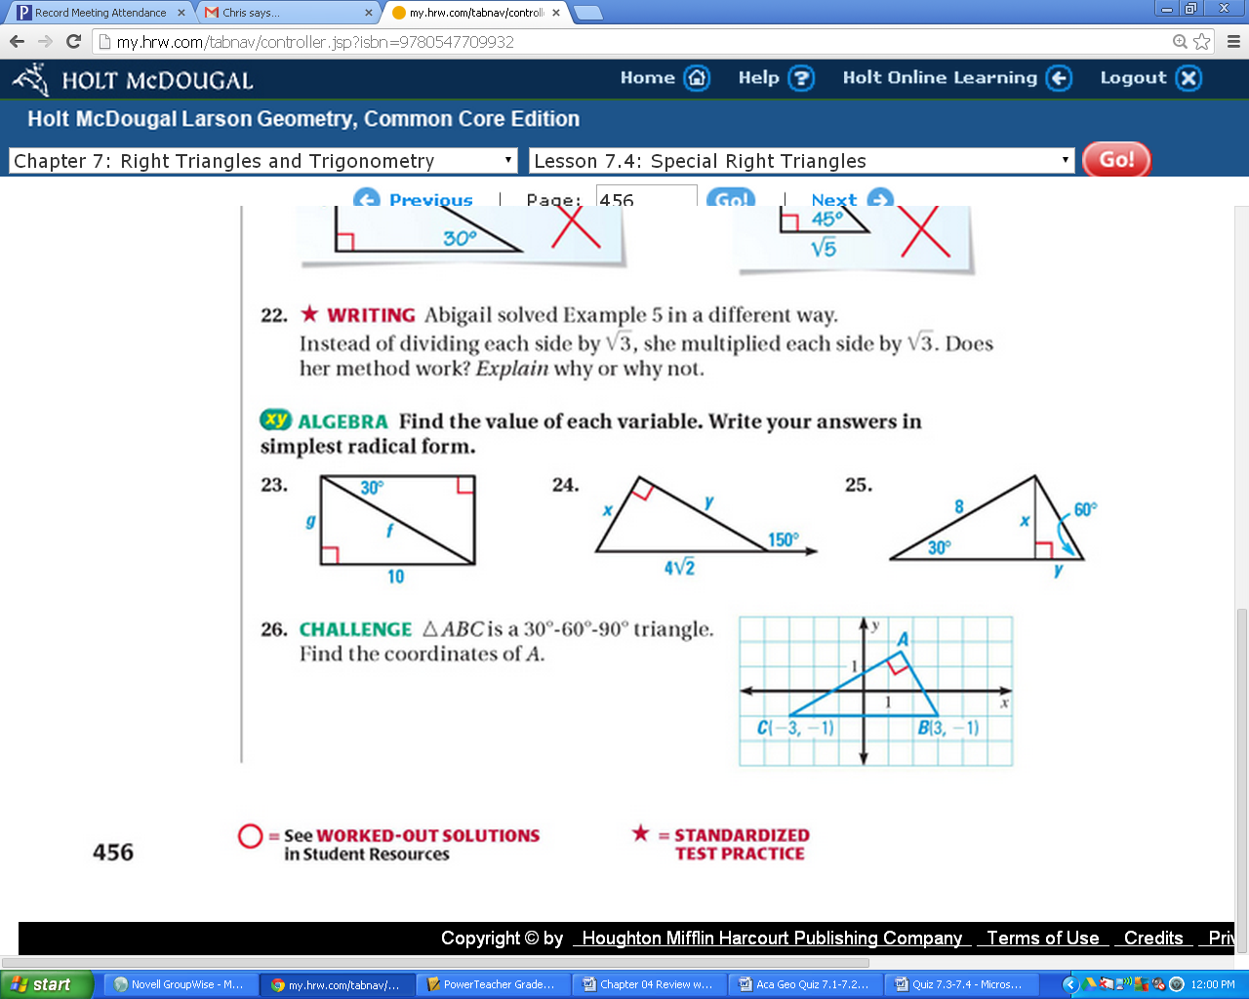

(9,-3)

(-9,-3)