1. 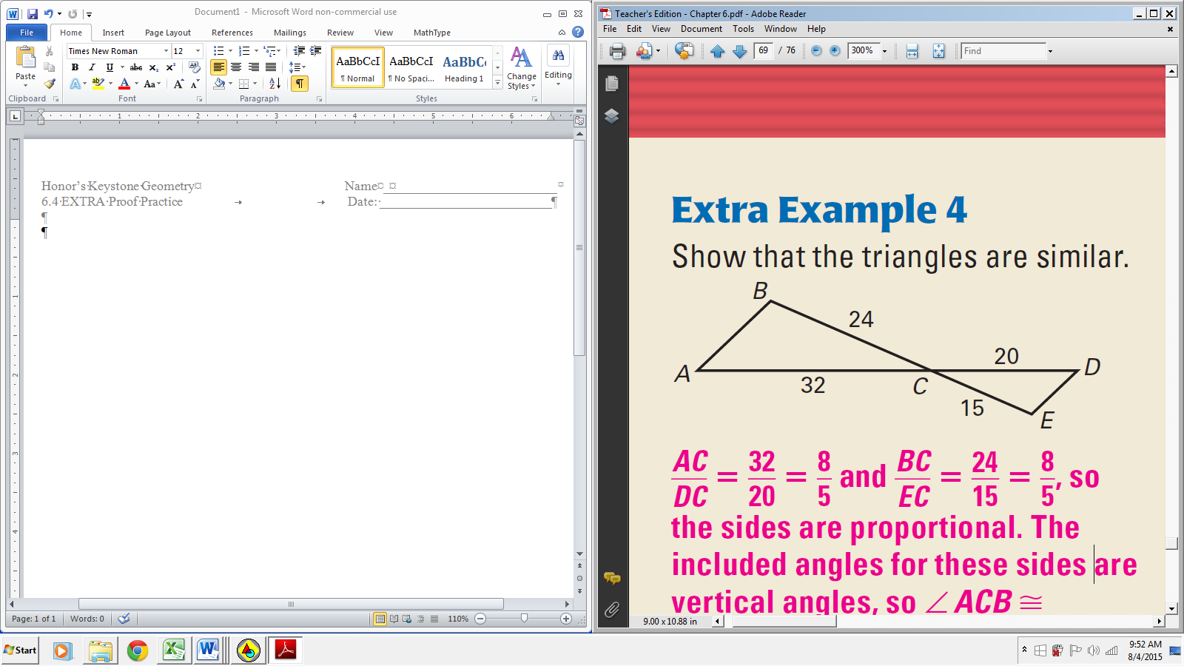Given: Diagram

Prove: 

|  |  |
| --- | --- |
| **Statements** | **Reasons** |
|  | 1. Given |
|  | 1. Vertical Angles Congr. Thm |
|  | 1. SAS~ |

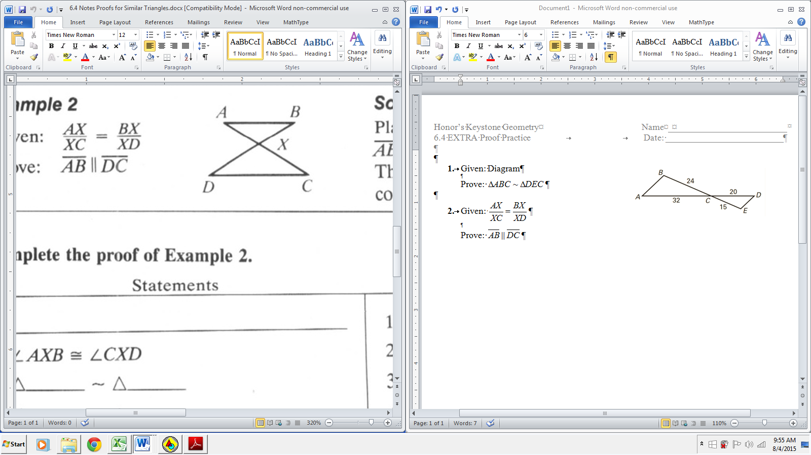

1. Given: 

Prove: 

|  |  |
| --- | --- |
| **Statements** | **Reasons** |
|  | 1. Given |
|  | 1. Vertical Angles Congr. Thm |
|  | 1. SAS~ |
| 1. (or ) | 1. Definition of ~ |
|  | 1. Alt. Int. Ang’s Thm Converse |

1. Given: 

Prove: 

|  |  |
| --- | --- |
| **Statements** | **Reasons** |
|  | 1. Given |
|  | 1. Reflexive Prop. |
|  | 1. SAS~ |
|  | 1. Definition of ~ |

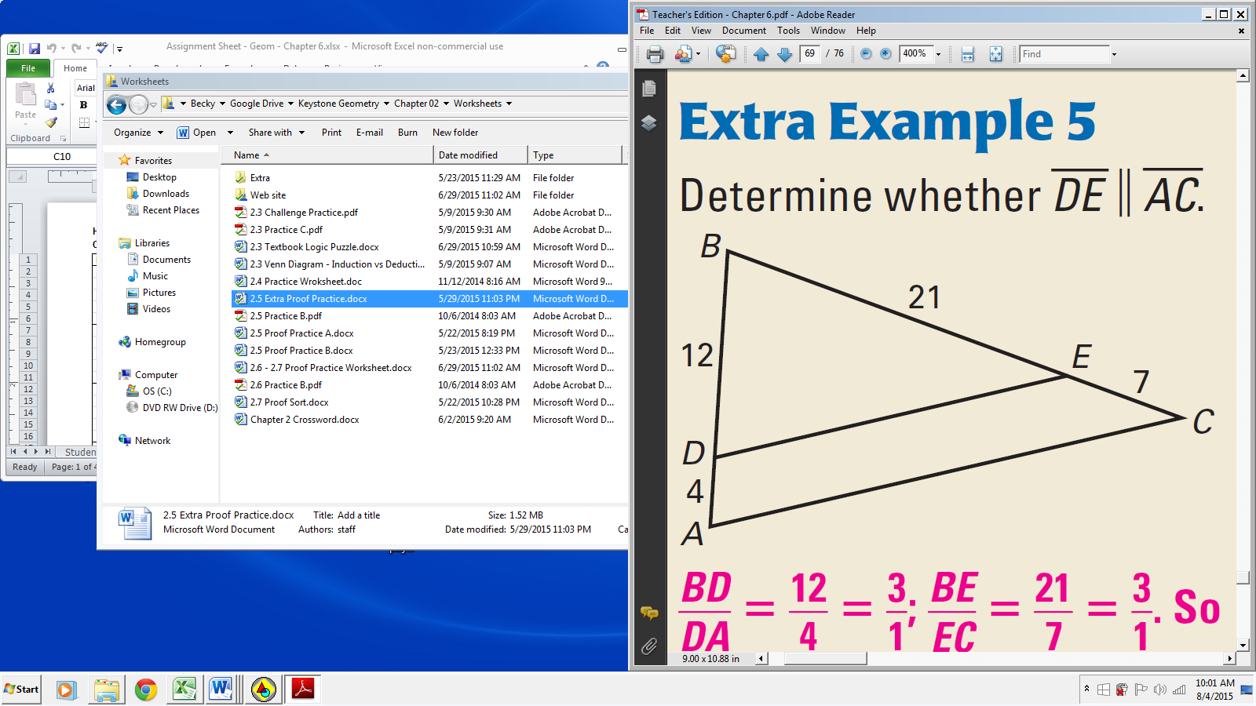

1. Given: Diagram

Prove: 

|  |  |
| --- | --- |
| **Statements** | **Reasons** |
|  | 1. Given |
|  | 1. Reflexive Prop. |
|  | 1. SAS~ |
| 1. (or ) | 1. Definition of ~ |
|  | 1. Corr. Ang’s Post. Converse |