1. 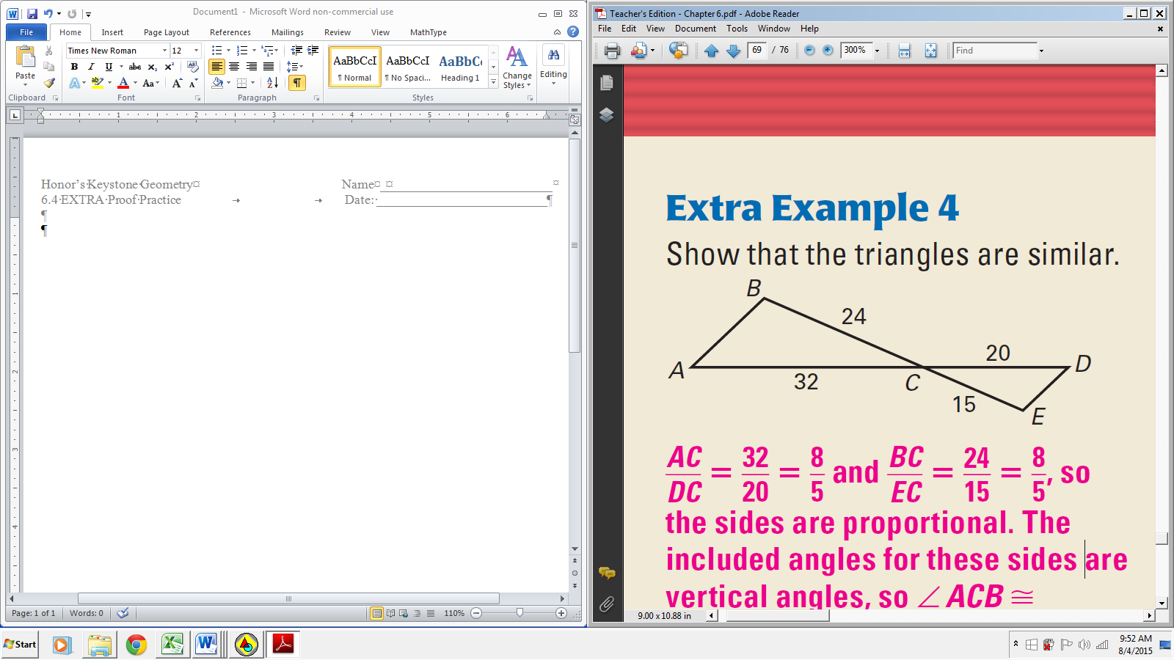Given: Diagram

Prove: 

|  |  |
| --- | --- |
| **Statements** | **Reasons** |
|  |  |
|  |  |
|  |  |

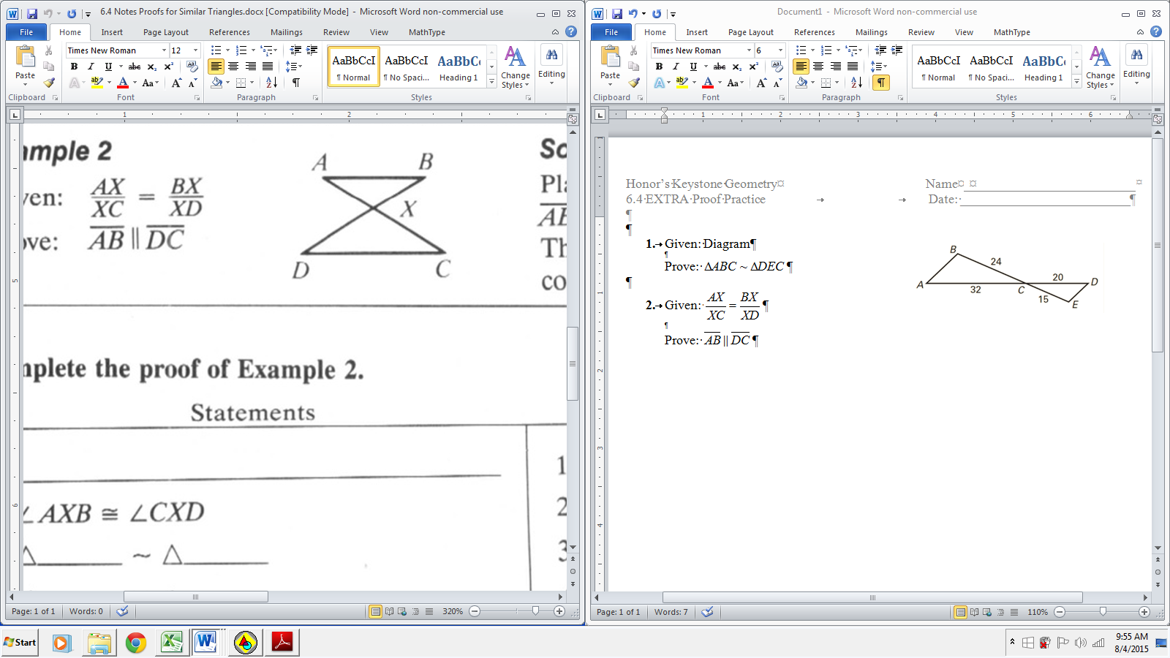

1. Given: 

Prove: 

|  |  |
| --- | --- |
| **Statements** | **Reasons** |
|  |  |
|  |  |
|  |  |
|  |  |
|  |  |

1. Given: 

Prove: 

|  |  |
| --- | --- |
| **Statements** | **Reasons** |
|  |  |
|  |  |
|  |  |
|  |  |

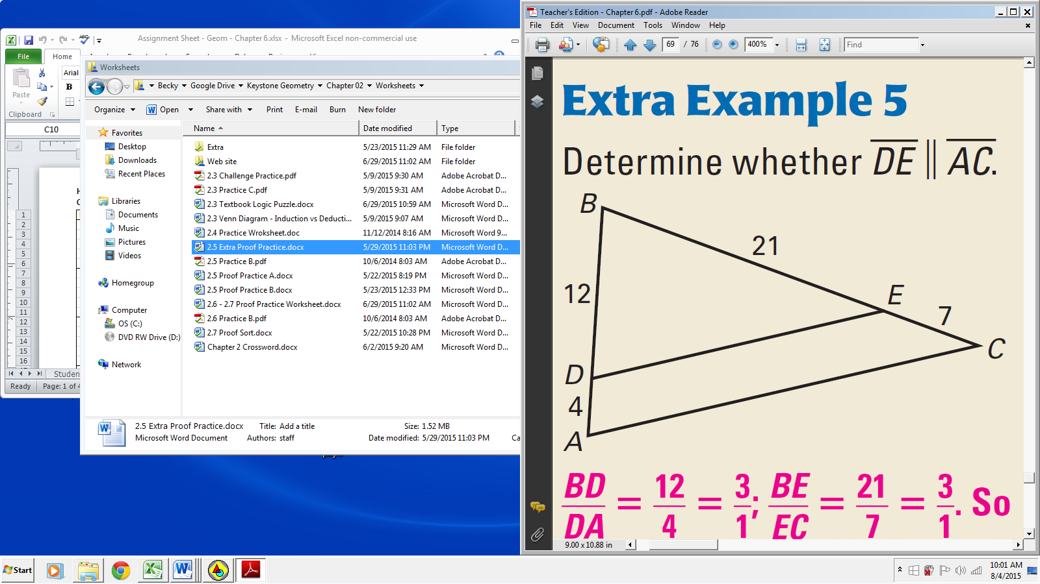

1. Given: Diagram

Prove: 

|  |  |
| --- | --- |
| **Statements** | **Reasons** |
|  |  |
|  |  |
|  |  |
|  |  |
|  |  |