**Name each of the following components of the triangle.**

|  |  |
| --- | --- |
| 2. Altitude: _____ 3. Angle Bisector: _____ 4. Median: _____ 5. Perpendicular   Bisector: _____ | 1. Altitude: _____ 2. Angle Bisector: _____ 3. Median: _____ 4. Perpendicular   Bisector: _____ |
| 1. Altitude: _____ 2. Angle Bisector: _____ 3. Median: _____ 4. Perpendicular   Bisector: _____ | 1. *E* is the midpoint of , *F* is the midpoint of , and *G* is the midpoint of . If the concurrency is not shown, say so. 2. Centroid: _____ 3. Circumcenter: _____ 4. Incenter: _____ 5. Orthocenter: _____ |

**Use the given information to answer each of the following**

1. 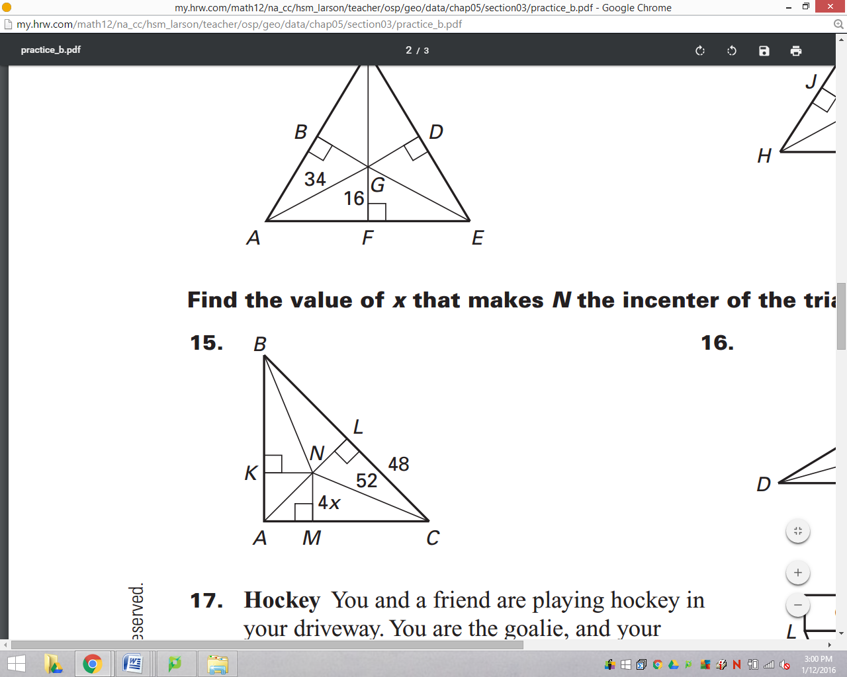If *N* is the incenter of the triangle, find the value of *x* and justify

your answer with a theorem, postulate, or definition.

1. If *L* is the centroid of the triangle and , find the value of *x* and justify your answer with a theorem, postulate, or definition.

