Decide whether or not the triangles can be congruent. If so, write the congruence statement AND the postulate or theorem used. If not, write no congruence.

**I**

**G**

**D**

**B**

**B**

**3.**

**2.**

**1.**

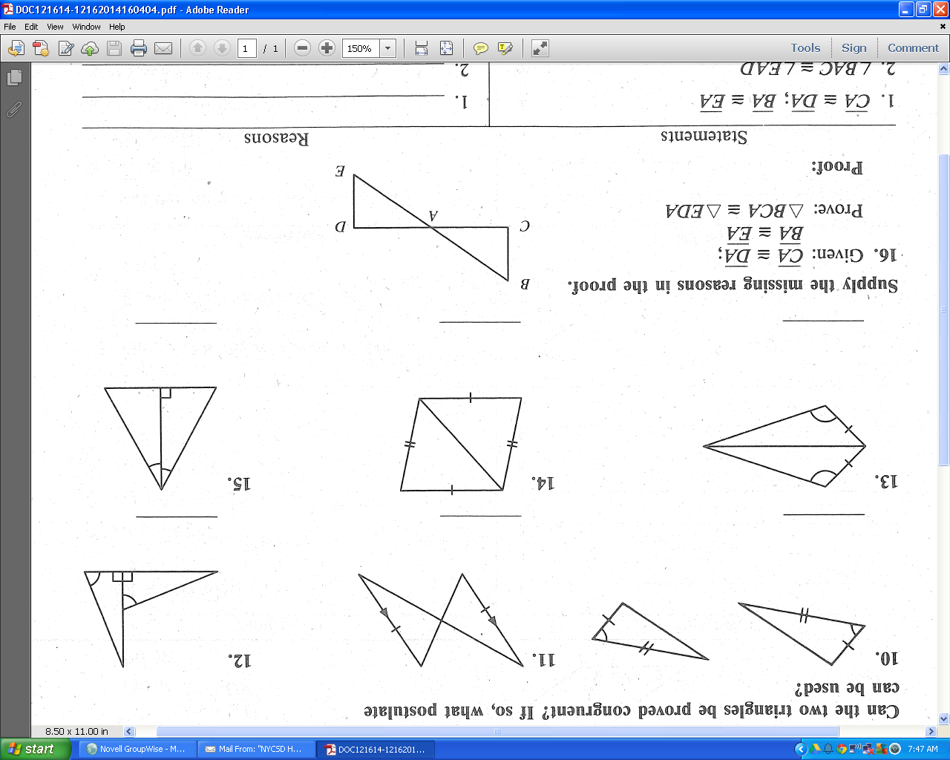

**M**

**L**

**K**

**K**

**H**

**F**

**E**

**A**

**C**

**B**

**A**

**C**

**B**

**C**

**B**

**A**

**C**

**B**

**A**

**C**

**A**

**C**

**A**

**6.**

**5.**

**4.**













|  |  |  |
| --- | --- | --- |
| Honor’s Keystone Geometry | Name |  |
| 4.4-4.6 Congruent Triangles | Date |  |

Decide whether or not the triangles can be congruent. If so, write the congruence statement AND the postulate or theorem used. If not, write no congruence.

**I**

**G**

**D**

**B**

**B**

**3.**

**2.**

**1.**



**M**

**L**

**K**

**K**

**H**

**F**

**E**

**A**

**C**

**B**

**A**

**C**

**B**

**C**

**B**

**A**

**C**

**B**

**A**

**C**

**A**

**C**

**A**

**6.**

**5.**

**4.**











