**Use the given information to name the pair of lines that must be parallel. Justify your reasoning with a theorem or postulate. If there are no such segments, write *none*.**

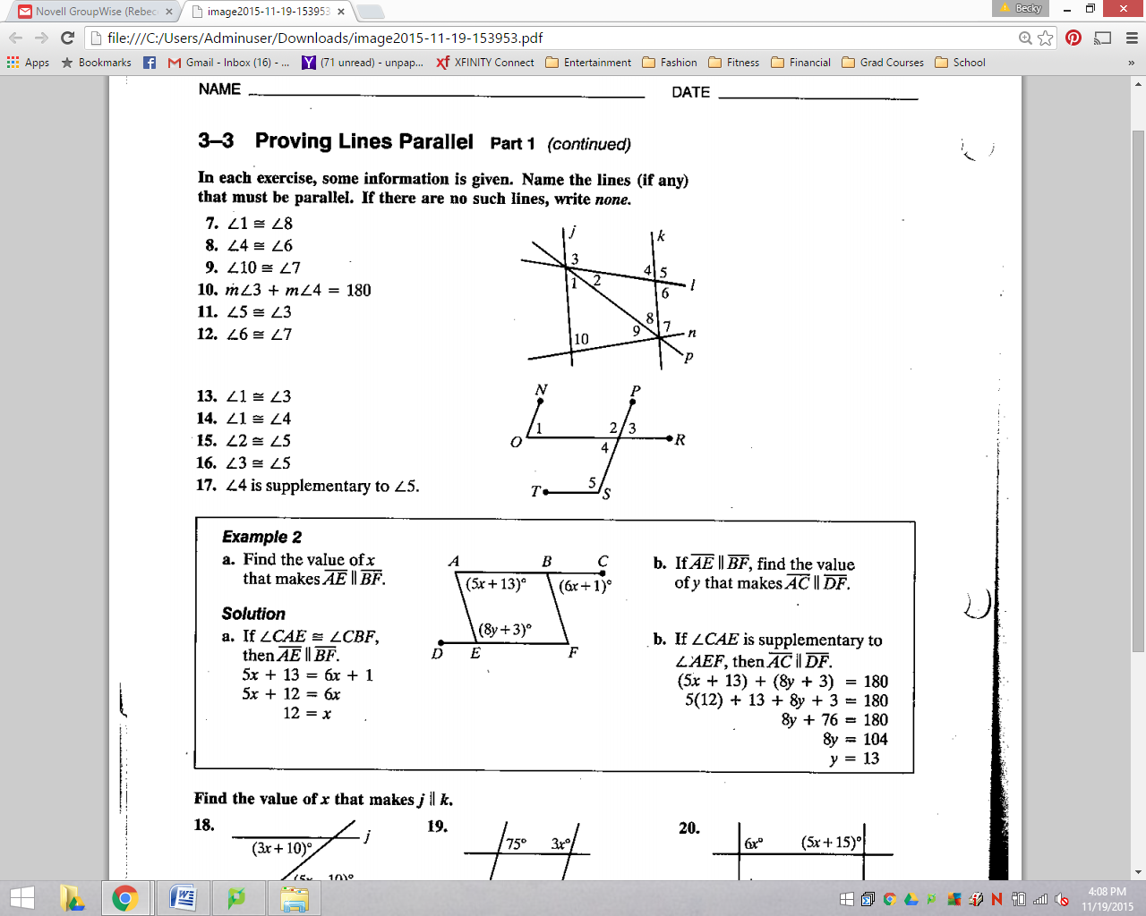

|  |  |  |  |
| --- | --- | --- | --- |
|  |  | **by** |  |
|  |  | **by** |  |
|  |  | **by** |  |
|  |  | **by** |  |
|  |  | **by** |  |
|  |  | **by** |  |



|  |  |  |  |
| --- | --- | --- | --- |
|  |  | **by** |  |
|  |  | **by** |  |
|  |  | **by** |  |
|  |  | **by** |  |
|  |  | **by** |  |

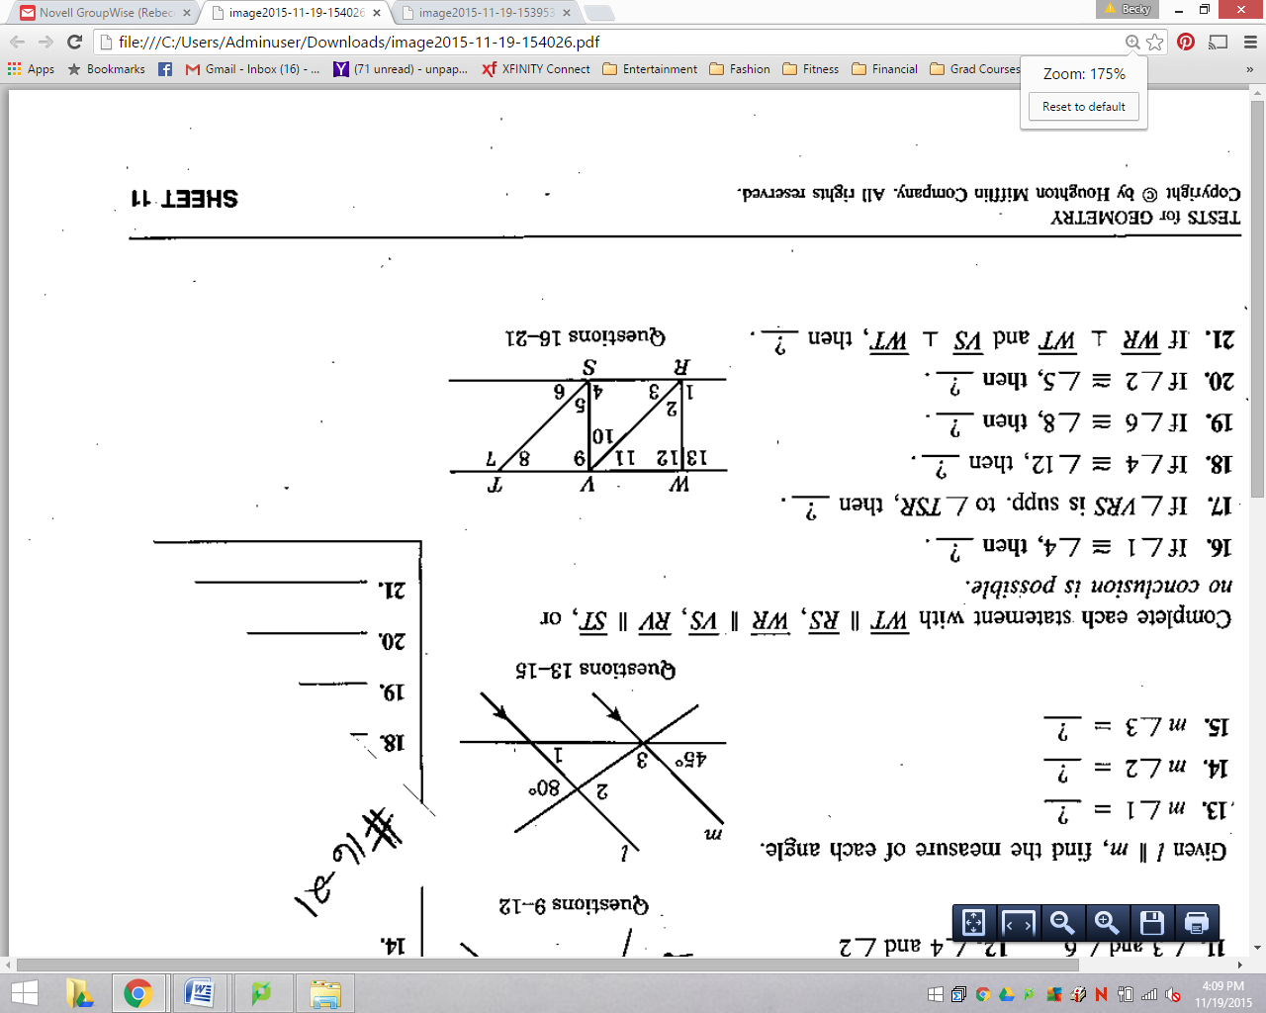

|  |  |  |  |
| --- | --- | --- | --- |
|  |  | **by** |  |
|  |  | **by** |  |
|  |  | **by** |  |
|  |  | **by** |  |
|  |  | **by** |  |
|  |  | **by** |  |