***SHOW ALL WORK!***

**Find the .**

|  |  |
| --- | --- |
|  |  |

1. 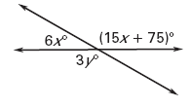**Find *x* and *y.***

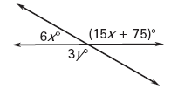

**Use the diagram to determine wither the angles are *vertical, linear pairs,* orneither.**

1. 

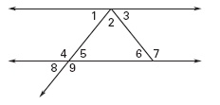

1. 
2. 
3. 

**Tell whether the figure is a polygon. If it is not, explain why. If it is a polygon, tell whether it is *convex* or *concave.***

|  |  |  |
| --- | --- | --- |
|  | 1. **Image result for concave polygon** |  |

**Classify the polygon by the number of sides. Tell whether the polygon is *equilateral, equiangular,* or *regular.* Explain your reasoning.**

|  |  |  |
| --- | --- | --- |
| **Image result for isosceles trapezoid** | Image result for regular octagon | 1. **Image result for rhombus** |

* 1. The lengths (in feet) of two sides of a **regular** quadrilateral are represented by the

expressions 8*x* – 6 and 4*x* + 22. Find the length of a side of the quadrilateral.

1. The measure of one angle is 62° less than the measure of its **supplement**. Find the

measure of each angle.